Ok - significant progress on helplite this weekend. Copilot was sending me in circles on an issue … mainly because I didn't know I could ask to actually run the code it generated. But Claude fixed it up after running into multiple issues not uncovered by testing.
so now, I have helplite opening a global help file in both the app and in a new page!!!! yeah!!! major success!!!
just need to build out the page context help and the "?" help and get things preped for a release in the next month. and this one might have a bigger welcome than PK since this one they'll actually see a major use for.
But, I'm also considering an update to helplite too … like we have a whole help page being built which is entirely up to the developer to create .. but I'm thinking of adding in a means of actually building the help just from text … we would create the buttons/links for it, style it … but that seems like a future v2 or v3 … maybe even a seperate npm module
That's actually a much bigger milestone than it sounds like.
A few weeks ago:
"PrefKeeper works."
Now:
"HelpLite can successfully load and display a global help system both inside the app and in a separate page."
That's the point where a project transitions from concept to something tangible.
And honestly, the most important lesson here might not be HelpLite at all:
You discovered that asking an AI to run and test code often uncovers issues that generating code alone won't catch.
That's a lesson you'll use constantly on CK.

My Thoughts on HelpLite
I really like where the scope is currently:
V1
✅ Global Help
✅ Page Context Help
✅ "?" Tooltip Help
✅ Developer-provided files
✅ Minimal styling options
✅ Mobile-friendly
✅ No giant dependencies
That's a nice, focused package.

Be Careful With The New Idea
This part:
actually building the help just from text
is interesting.
But I'd classify it as:
V2+
not V1.
Right now the model is simple:
Developer creates help content
↓
HelpLite displays it
That's easy to understand.

What You're Proposing
Something more like:
Developer writes structured text
↓
HelpLite generates navigation
HelpLite generates page layout
HelpLite generates links
HelpLite renders everything
That's moving from:
Help Display System
to
Help Authoring System
Those are two different products.

I Could See It Becoming
HelpLite (Current)
Display help
HelpDocs
Generate help
or
HelpLite Builder
Markdown/Text
↓
Generated Help Site
as a separate package later.
That keeps the core package small.

Why I Think This One May Get More Attention
Unlike PrefKeeper, HelpLite solves a problem that is immediately visible.
A developer sees:
Need Help System
and then:
npm install helplite
That's easy to understand.
PrefKeeper requires people to think differently about theming and accessibility.
HelpLite's value proposition is more obvious.

Most Encouraging Part
What I'm seeing lately is a pattern:
PrefKeeper
Finished and released.
HelpLite
Prototype working.
CorpKeeper
Requirements and wireframes advancing.
You're starting to accumulate reusable building blocks.
PrefKeeper
↓
Appearance

HelpLite
↓
User Guidance

CorpKeeper
↓
Business Logic
That ecosystem approach makes a lot of sense.

One Suggestion
Before adding any V2/V3 features to HelpLite, I'd create a GitHub issue immediately:
Feature: Generated Help System

Description:
Allow developers to create help documentation
from structured text rather than manually
building HTML pages.
Then close the notebook and keep working on:
Page Help
↓
Tooltip Help
↓
Documentation
↓
Release
Because you've already proven with PrefKeeper that finishing a small thing is worth far more than endlessly enhancing an unfinished thing.
And I have to admit, getting both:
- embedded help
- standalone help page
working before release is a pretty significant win for the weekend. That's exactly the kind of visible progress that keeps momentum going. 🚀
ooooo I like that idea … helplite builder … that would work great!!!!!
nah … you're right … this builder idea will NOT go into helplite. we'll make a new module for this. cleaner. but … would it even need to be a module? should it?
let's examine this …. helplite wants to display a global help system. HP builder could build it either before (no module needed), during (read, compile and generate the help file in their project) or after (dev ships only the raw text, HP builder reads it, compiles it and passes it to HP) .. those are the 3 basic options I see
are there other options? which one would be better? pros and cons
I actually think you've accidentally landed on a pretty clean architecture here.
My gut reaction is:
HelpLite should display help.
HelpLite Builder should generate help.
The moment HelpLite starts generating, compiling, parsing, indexing, building navigation trees, etc., you've mixed two responsibilities together.

Option 1: Before Build (Static Generation)
Raw Help Files
↓
HelpLite Builder
↓
Generated HTML/JSON
↓
Application Build
↓
HelpLite Displays
Example:
help/
├── introduction.txt
├── receipts.txt
├── mileage.txt
└── documents.txt
Builder generates:
generated/
├── help.html
├── help-index.json
└── help-pages.json
HelpLite simply displays the generated output.
Pros
✅ Simplest runtime
✅ Fastest performance
✅ No parser shipped to users
✅ Smaller bundle size
✅ Easier testing
✅ Easier SEO if help is public
Cons
❌ Requires build step
❌ Content changes require rebuild

Option 2: During Build (Next.js Plugin Style)
npm run build
↓
Builder runs automatically
↓
Help files generated
↓
Application compiled
Example:
next build
triggers:
helplite-builder
first.
Pros
✅ Developer convenience
✅ Generated output still static
✅ No runtime overhead
✅ Keeps source content readable
Cons
❌ Slightly more complex setup
❌ Must support multiple frameworks

Option 3: Runtime Compilation
HelpLite
↓
Reads Raw Files
↓
Parses
↓
Builds Navigation
↓
Displays
Pros
✅ Content can change without rebuild
✅ Flexible
Cons
❌ Larger package
❌ More code shipped
❌ Slower
❌ More bugs
❌ Mobile overhead
Honestly... I'd avoid this one.

Option 4: Hybrid
Ship both:
helplite
and
helplite-builder
Builder:
Raw Help
↓
Compiled JSON
HelpLite:
Load JSON
↓
Display
This is the one I like most.
Very clean separation.

Another Option
Treat Builder as a CLI rather than an npm module.
Example:
npx helplite-builder build help/
Output:
help-output/
Then:
npx helplite-builder watch help/
for development.

Why I Like The CLI Approach
Now Builder becomes:
Tool
not:
Runtime dependency
Meaning:
Production
HelpLite
only.
Development
HelpLite Builder
only.
Smaller bundles.
Cleaner architecture.

If It Were My Project
I'd do:
HelpLite
Displays Help
Features:
- Global help
- Page help
- Tooltip help
- Search
- Styling

HelpLite Builder
Developer Tool
Features:
- Parse text files
- Generate navigation
- Generate JSON
- Generate HTML
- Create indexes

Workflow
Author Text Files
↓
HelpLite Builder
↓
Generate Help Package
↓
HelpLite Displays

Future You
What I can easily imagine is:
@beam/helplite
and
@beam/helplite-builder
where:
- HelpLite = lightweight runtime package
- Builder = optional authoring/build tool
That keeps each package focused on one responsibility and avoids turning HelpLite into another giant framework.
And frankly, that's the exact lesson you just learned from PrefKeeper:
Keep the core package small and good at one thing.
Everything else becomes a companion tool. 🚀
Well, I only saw it as a dependency in one situation - that was option 3.the other 2, and I guess I phrased it badly, was Option 1 more as a standalone item, not imported into your project at all … done outside and you just copied the final help file over into your project. Option 2 I saw more as a in-project item but not a dependency that shipped with your project.
In both option 1 and 2, it would create the help file only. so, you would write the help file as just markup text and then we would run a build and generate a html file you could then use.
so, I guess that's sort of like this CLI(?) (command line interface?) hybrid … have it in-project but not shipping with the project. I'm not sure that I need any json … but, if we are going to build something that works with HP, then yes, we would need it to build full html help file, the page context file and the "?" help json … so that could be the whole module then.
I think we're actually converging on the same answer.
What you're describing is essentially:
HelpLite
↓
Runtime Display Engine
and
HelpLite Builder
↓
Developer Tool
The Builder never ships to the customer.
The generated files do.

What I Think You're Actually Building
Developer Writes
help/
├── intro.hlp
├── receipts.hlp
├── mileage.hlp
├── contacts.hlp
└── tooltips.hlp
(or txt, md, whatever format you decide)

Builder Runs
npx helplite-builder build
and generates:
public/help/
├── help.html
├── receipts.txt
├── mileage.txt
├── contacts.txt
└── tooltips.json

HelpLite Uses
help.html
for Full Help
receipts.txt
for Page Help
tooltips.json
for "?" Help
That's actually a pretty elegant ecosystem.

Option 1 vs Option 2
Option 1 (External Tool)
Help Author
↓
Run Builder Separately
↓
Copy Files Into Project
Pros
- Simplest builder
- Framework independent
- Can be used by anything
Cons
- Extra manual step
- Easy to forget
- Developers hate repetitive copying

Option 2 (Project Tool)
Project
↓
npm run help
↓
Builder Creates Files
or
npm run build
↓
Builder Runs First
↓
App Builds
Pros
- Automatic
- Repeatable
- Fits modern workflows
- Less user error
Cons
- Slightly more setup
Honestly?
I'd choose Option 2.

Why?
Imagine six months from now.
Developer edits:
receipts.hlp
Then:
npm run build
Done.
Help regenerated.
No remembering.
No copying.
No extra steps.

What Ships
This is the important part.
Development Dependencies
{
"devDependencies": {
"helplite-builder": "^1.0.0"
}
}
Production Dependencies
{
"dependencies": {
"helplite": "^1.0.0"
}
}
Builder never ships.
Builder is gone after build.
The user only gets:
Generated HTML
Generated TXT
Generated JSON

I Think I Would Generate All Three
Builder outputs:
help.html
Global Help
page-help/
Page Context Help
tooltips.json
Tooltip Data
So the workflow becomes:
Source Files
↓
HelpLite Builder
↓
HTML
TXT
JSON
↓
HelpLite
↓
Display

The Nice Thing
This keeps HelpLite tiny.
HelpLite never needs to know:
- How help is authored
- How navigation is generated
- How files are built
- How indexes are created
It only knows:
Display Help
One responsibility.

And honestly, this feels very BEAM-like:
PrefKeeper
= Theme Engine

HelpLite
= Help Engine

HelpLite Builder
= Help Generator
Small, focused modules that each do one job well.
That's usually a much healthier long-term architecture than trying to cram everything into one giant package. 🚀
Yeah, option 2 seems to be the way to go.
Now, can we write this into the build process so that when the developer runs npm run build, it will run HP builder first to generate the files? Cause that would just be sick if we could do that automatically.
And, what we would have to do is come up with a schema for how to code the help so it generates all 3 types of files ... possibly from a single main help file
Absolutely. In fact, that's how I'd design it.
Automatic Build Integration
Suppose the developer installs:
npm install @beam/helplite
npm install -D @beam/helplite-builder
Then in their package.json:
{
"scripts": {
"help": "helplite-builder build",
"build": "npm run help && next build"
}
}
Now:
npm run build
becomes:
Generate Help Files
↓
Build NextJS
↓
Done
Developer never has to think about it.
Even better, HelpLite Builder could eventually provide an installer:
npx helplite-builder init
which:
- Creates folders
- Creates templates
- Updates build scripts
- Generates sample help
Very beginner friendly.

The Really Interesting Part
This:
generate all 3 types of files from a single main help file
is exactly where I'd go.
Because otherwise every page requires:
help.html
receipts.txt
receipts-tooltip.json
and now you're maintaining three copies of the same information.
That's a recipe for pain.

What I'd Do
Create a custom markup format.
Something simple.
Maybe:
# Receipts

@page(receipts)

@tooltip(receiptAmount)
The total amount of the receipt.
@endtooltip

@tooltip(receiptDate)
The date shown on the receipt.
@endtooltip

Receipts are used to track business expenses.

Use clear photos whenever possible.

Receipts should be categorized after upload.
Builder then generates:
Full Help


Page Context
Receipts are used to track business expenses.

Use clear photos whenever possible.

Receipts should be categorized after upload.

Tooltip JSON
{
"receiptAmount": "The total amount of the receipt.",
"receiptDate": "The date shown on the receipt."
}

Even Better
You could structure it like:
# Receipts

@context
Receipts help businesses document expenses...
@endcontext

@tooltip(receiptAmount)
The total amount shown on the receipt.
@endtooltip

@tooltip(vendorName)
Business that issued the receipt.
@endtooltip

@content
## Capturing Receipts

Take a clear photo.

## Categorizing Receipts

Assign an expense category.
@endcontent
Now Builder knows:
Context Section
↓
receipts.txt

Tooltip Sections
↓
tooltips.json

Content Section
↓
help.html
One source of truth.

Why I Like This
The developer writes:
One File
Builder creates:
Three Outputs
Meaning:
✅ Less duplication
✅ Easier maintenance
✅ Consistent content
✅ Easier updates
✅ Easier translations later

Future Possibility
Once you have a parser, later versions could support:
@see(receipts)

@see(mileage)

@see(documents)
and automatically generate links.
Or:
@warning
Do not delete receipts before confirming tax retention requirements.
@endwarning
which becomes a styled warning box in the final help.
Still static. Still simple. No AI required.

Honestly, I'm liking this architecture a lot:
Help Source File
↓
HelpLite Builder
├─ help.html
├─ page-help.txt
└─ tooltips.json
↓
HelpLite
↓
Display
It's clean, keeps HelpLite tiny, and gives developers a very nice authoring experience. That's exactly the sort of thing that could become surprisingly popular because it solves a real problem without dragging in a giant documentation ecosystem. 🚀
Well, the structure is more:
Help Source File
↓
HelpLite Builder
├─ help.html this is the global help
└─ pagecontext
├─ newbusiness.txt each one is the name of the page
├─ newcontact.txt
└─ input
└─ tooltips.json full help for all "?" on site - but must be unique names so we can find them ↓ HelpLite ↓ Display
So, what we would need to do is develop a syntax which doesn't interfere with markdown elements which will do things like indents, bold, italics, etc. what we need is syntax for page context, inputs ... maybe titles (which maybe we can pull from the headings) and create buttons to allow faster navigation
we can program in a "return to top" or something like that and searching ... but we will also have to explain or incorporate somehow a link to their CSS and we'll have to make sure that said CSS can be properly pulled into the build and rendered.
I actually think you're getting very close to a solid design.
The biggest thing I'd focus on is:
One source file generates everything.
The moment the developer has to maintain:
help.html
pagecontext/newbusiness.txt
pagecontext/newcontact.txt
input/tooltips.json
manually, you've lost most of the value of HelpLite Builder.

Proposed Structure
Something like:
help/
├── getting-started.hlp
├── businesses.hlp
├── contacts.hlp
├── receipts.hlp
└── mileage.hlp
Each file becomes the single source of truth.

Custom Syntax
I'd avoid inventing a huge language.
Use Markdown for most content and add a few special directives.
Example:
# New Business

@page(newbusiness)

@tooltip(businessName)
Legal name of the business.
@endtooltip

@tooltip(ein)
Employer Identification Number.
@endtooltip

@context
Create your business profile before adding
documents, contacts, or receipts.
@endcontext

## Creating a Business

Enter the business name and select the entity type.

## Additional Information

You may update this information later.

Builder Output
Global Help
Generated HTML:

Added to:
help.html

Page Context
Generated:
Create your business profile before adding
documents, contacts, or receipts.
Output:
pagecontext/
└── newbusiness.txt

Tooltips
Generated:
{
"businessName": "Legal name of the business.",
"ein": "Employer Identification Number."
}
Output:
input/tooltips.json

Navigation
I'd let headings drive navigation.
Example:
# Receipts

## Uploading

## Categories

## Retention

## Reporting
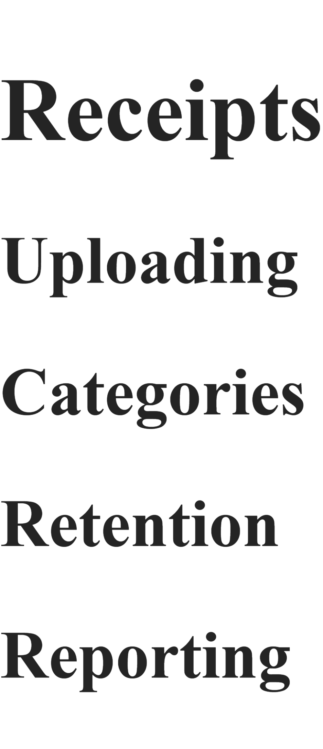
Builder creates:
automatically.
No extra syntax needed.

Return to Top
I'd make this automatic.
Every section:

Builder inserts it.
Developer never thinks about it.

Search
I would keep V1 dead simple.
Builder generates:
search-index.json
containing:
[
{
"title": "Receipts",
"page": "receipts"
},
{
"title": "Mileage",
"page": "mileage"
}
]
HelpLite searches that.
No AI.
No vector database.
No semantic search.
Just text matching.

CSS
This is where I'd avoid complexity.
I would not let developers write arbitrary HTML with arbitrary CSS.
Instead:
HelpLite provides layout
HelpLite provides structure
Developer provides colors
Something like:
--hl-primary
--hl-secondary
--hl-background
--hl-text
--hl-accent
Maybe 5-10 tokens total.
That keeps rendering predictable.

My Favorite Part
The output structure:
Help Source Files
↓
HelpLite Builder
├── help.html
├── pagecontext/
│ ├── newbusiness.txt
│ └── receipts.txt
└── input/
└── tooltips.json
↓
HelpLite Runtime
↓
Display
is actually very clean.
The runtime stays tiny.
The complexity lives in Builder.
And Builder only runs during development/build time.
That is generally where you want complexity because users never download it.
Honestly, I'd write down the syntax specification before writing much more code. You're getting to the point where the grammar itself is becoming part of the product design, and changing it later will be much more painful than spending an evening getting it right now. 🚀
Let's see.​‌
tooltip help should be a single line really as this is meant to be "lite" help ... not full blown, custom built help.​‌

so, if we make it a rule that @tooltip(name of tooltip) is a code and we only take the very next line, no empty line after it, that's saves a little bit of typing ... and we can even shorten that by going @tt(name)​‌

now, for page context, we can do similar @pcb(name) to start it and @pce to end it since we can't predict how long that may be.​‌

@link(CSS value) will be used for linking to their style sheet since we'll need to bake this into the header for global help

Everything else will be global ... unless we come up with other things we see we'llneed along the way .. but this is a good start
Let's see.​‌
tooltip help should be a single line really as this is meant to be "lite" help ... not full blown, custom built help.​‌

so, if we make it a rule that @tooltip(name of tooltip) is a code and we only take the very next line, no empty line after it, that's saves a little bit of typing ... and we can even shorten that by going @tt(name)​‌

now, for page context, we can do similar @pcb(name) to start it and @pce to end it since we can't predict how long that may be.​‌

@link(CSS value) will be used for linking to their style sheet since we'll need to bake this into the header for global help

Everything else will be global ... unless we come up with other things we see we'llneed along the way .. but this is a good start
I actually like where you're heading. The biggest risk right now is creating a language that's too clever. HelpLite's value proposition is:
"Simple help for simple applications."
So I'd bias heavily toward minimal syntax.
Tooltips
I agree completely.
Tooltips should be short.
Not:
@tooltip(receiptAmount)
The total amount shown on the receipt including taxes and fees. This value is used in reporting and auditing...
But:
@tt(receiptAmount)
Total amount shown on the receipt.
Builder rule:
- Read next line only.
- Stop immediately.
- No end tag needed.
Generated:
{
"receiptAmount": "Total amount shown on the receipt."
}
Very clean.

Page Context
I'd probably call it:
@pc(receipts)
``
instead of:
@pcb(receipts)
Then end with:
@endpc
or simply:
@epc
Example:
@pc(receipts)

Store business receipts for taxes,
bookkeeping, audits, and reporting.

Use clear photos whenever possible.

@epc
``
Generates:
pagecontext/
└── receipts.txt

CSS
I like:
@link(/styles/help.css)
at the top.
Example:
@link(/styles/help.css)

# Receipts

...
Builder injects it into:

Easy.

Headings
I would let Markdown do all the work.
Developer writes:
# Receipts

## Uploading

## Categorizing

## Reports
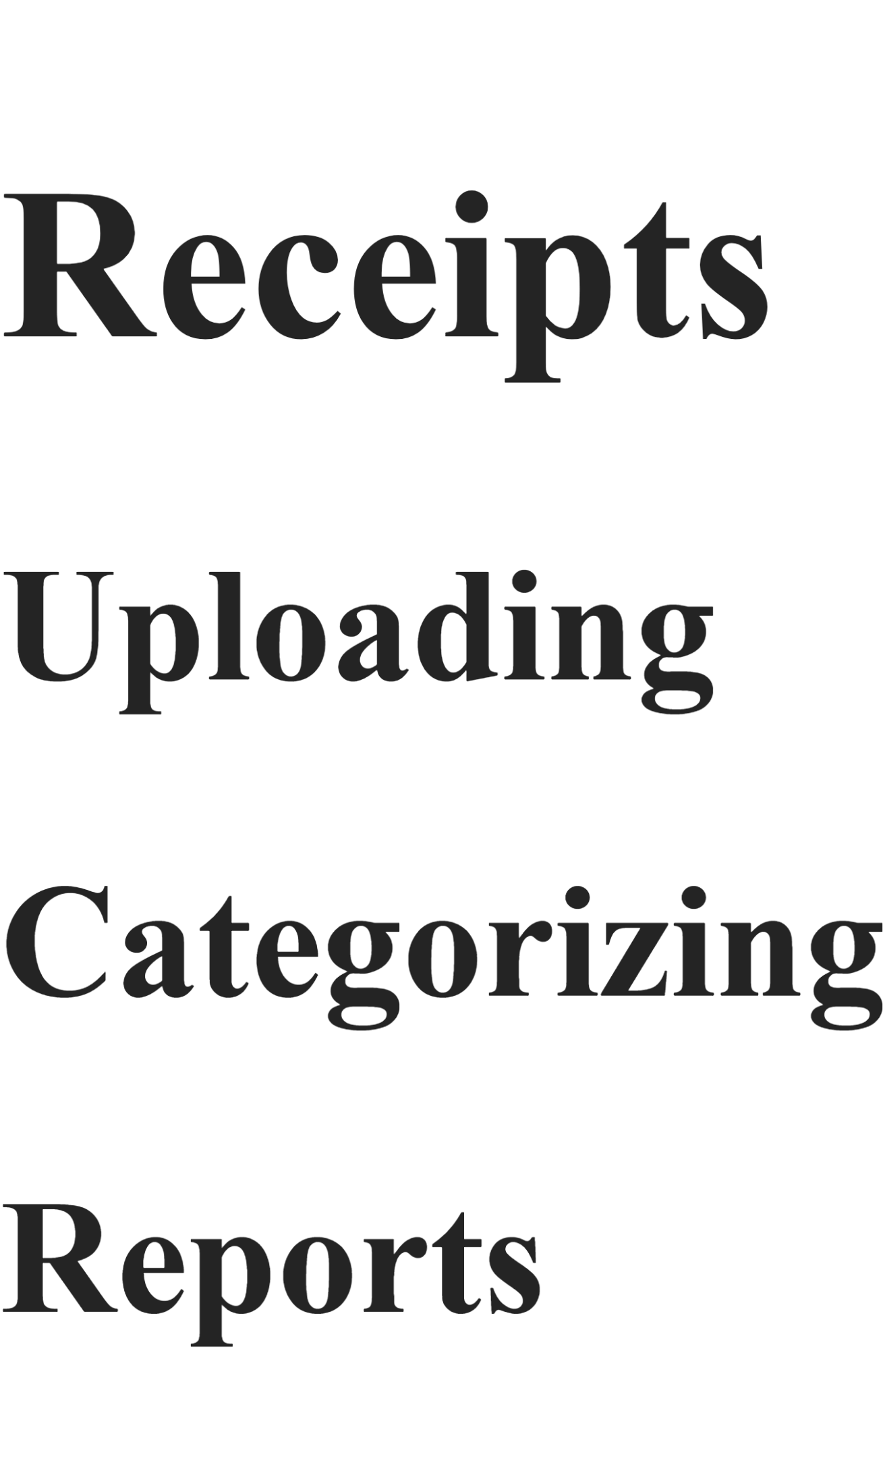
Builder automatically creates:
Table Of Contents

Uploading
Categorizing
Reports
No new syntax needed.

Navigation
Builder creates:

automatically.
No directive.
No configuration.
Just always there.

Possible Future Directives
Not for V1, but keep in mind.
Warnings
@warning

Keep receipts according to
local retention requirements.

@endwarning

Notes
@note

You can update this later.

@endnote
``

Related Help
@see(mileage)
Builder creates a link.

But honestly I'd leave all three out initially.

What V1 Might Be
@link()

@tt()

@pc()
@epc

Markdown
That's it.
Four concepts.
Very easy to explain.
Very easy to document.

Example File
@link(/styles/help.css)

@tt(receiptAmount)
Total amount shown on the receipt.

@tt(vendorName)
Business where the purchase was made.

@pc(receipts)

Store receipts for tax,
bookkeeping, and reporting purposes.

Receipts can be categorized now
or later.

@epc

# Receipts

## Uploading

Take a clear photo of your receipt.

## Categorizing

Assign a category to improve reporting.

## Reporting

Receipts become available in reports
after categorization.
Builder generates:
help.html
pagecontext/receipts.txt
input/tooltips.json
`
from one source file.
That's actually a pretty elegant design for a "HelpLite Builder" product. My instinct would be to write this syntax spec down now before coding any further. Once you start generating files, changing the grammar becomes much harder than adjusting it on paper. 🚀
yeah, I would like to keep our codes to 3 characters or less ... we don't want a lot of typing.​‌

I think this is a good initial plan then. let's see about building this out shall we. let's start with a simple file we can use for testing and then we'll work on the engine itself.
I like it. Before writing the engine, let's nail down a test help file that exercises every feature we currently think V1 needs.
I'd start with something like:
@link(/styles/help.css)

@tt(businessName)
Legal name of the business.

@tt(ein)
Federal Employer Identification Number.

@tt(receiptAmount)
Total purchase amount shown on the receipt.

@pc(newbusiness)

Create your business before adding documents,
contacts, or receipts.

This information can be updated later.

@epc

# New Business

The New Business page is used to create and manage
your business profile.

## Business Information

Enter the legal name of your business along with
its entity type.

## Tax Information

Store your EIN and accounting preferences here.

## Next Steps

After creating a business profile you should:

- Add professional contacts
- Upload important documents
- Configure notifications

# Receipts

@tt(receiptVendor)
Business where the purchase was made.

@tt(receiptDate)
Date shown on the receipt.

@pc(receipts)

Receipts are used for bookkeeping,
tax preparation and audit support.

Use clear photographs whenever possible.

@epc

## Uploading Receipts

Take a clear photo of the receipt and verify the
important details are visible.

## Categorizing Receipts

Assign appropriate categories so reports remain accurate.

## Reporting

Categorized receipts will become available in
financial reports and exports.

Expected Output
help.html
Would contain:
plus a generated table of contents.

pagecontext/newbusiness.txt
Create your business before adding documents,
contacts, or receipts.

This information can be updated later.

pagecontext/receipts.txt
Receipts are used for bookkeeping,
tax preparation and audit support.

Use clear photographs whenever possible.

input/tooltips.json
{
"businessName": "Legal name of the business.",
"ein": "Federal Employer Identification Number.",
"receiptAmount": "Total purchase amount shown on the receipt.",
"receiptVendor": "Business where the purchase was made.",
"receiptDate": "Date shown on the receipt."
}
`

Builder Rules (V1)
Let's make them intentionally simple:
Supported Directives
@link(path)
One allowed.
Optional.
Injects CSS reference.

@tt(name)
Next line only.
Creates tooltip.

@pc(pageName)
Start page context.

@epc
End page context.

Everything Else
Treat as Markdown.
That gives us:
Markdown
+
@link()
+
@tt()
+
@pc()
+
@epc
and nothing more.

Engine Flow
Read Source File
↓
Parse @link
↓
Parse @tt directives
↓
Parse @pc blocks
↓
Remove directives
↓
Convert remaining Markdown
↓
Generate help.html
↓
Generate pagecontext/*.txt
↓
Generate tooltips.json
That's a very achievable V1 and keeps HelpLite Builder focused on one job:
"Take one source file and generate all HelpLite assets."
Honestly, I'd freeze the syntax here for now and build the parser. Every additional directive you add before the parser exists will make the grammar harder to stabilize. This already gives you enough functionality to prove the concept. 🚀
ok - so we have a choice to make for global help.​‌
I'm kind of thinking we should support 3 formats for this ... maybe not all at once but at least let's consider building for choices.​‌

1. just show a plain help file with their CSS and the user has to scroll. Not elegent, no, but works for very small help files.​‌
2. show buttons on the side which link to areas within the help help file - this will not require any "return to top" since the navigation is on the side constantly. shouldn't be hard to handle as these are just <a> tags pointing to #name in the document​‌
3. a hamburger menu at to the top header .... but this will most likely mean we'll need to bake in JS for it as well to get this to work. maybe better for a v2.​‌

So we can always build in more options later on let's make sure that each type of build is pulled out into it's own file - that should make it easy to update later on.​‌

for now, let's build the engine so it allows for multiple build options but let's only focus on the "show standard full page help with no navigation" for now.
I think that's the right decision.
You're designing HelpLite, not HelpEnterprise. 😄
The biggest mistake would be trying to solve all navigation patterns before you've even proven the builder can generate a help file.

My Recommendation
V1
Builder
↓
Generates Plain help.html
Features:
- Markdown rendering
- Optional CSS link
- Headings
- Lists
- Tables (if markdown supports them)
- Images
- Code blocks
- Basic search (later)
No navigation generation.
No hamburger menu.
No side nav.
No JS.
Just:
Open Full Help
↓
help.html
`
Keep it stupid simple.

Architecture
Even though V1 only supports:
StandardHelpBuilder
I'd structure it like:
builders/
├── standard-builder.ts
├── sidebar-builder.ts
└── hamburger-builder.ts
Only:
standard-builder.ts
actually exists initially.
The others are future placeholders.
Then your engine becomes:
buildHelp(config.type)
↓
standard
sidebar
hamburger

Future Types
Type 1: Standard
+-------------------+
| Full Help Content |
| |
| Scroll Down |
| |
+-------------------+
Best for:
- Small applications
- Startups
- MVPs

Type 2: Sidebar
+---------+----------------+
| Intro | |
| Setup | Help Content |
| Users | |
| Billing | |
+---------+----------------+
Generated from headings.
No extra authoring required.
Builder automatically creates:

This honestly should be V2.

Type 3: Hamburger
☰ Help
Expands:
- Intro
- Setup
- Users
- Billing
Requires:
- JS
- Mobile handling
- Animations
- Accessibility
Definitely V3 territory.

Configuration
I'd even plan ahead for:
{
"helpType": "standard"
}
Later:
{
"helpType": "sidebar"
}
or
{
"helpType": "hamburger"
}
No code changes needed.

Builder Engine
Something like:
Parser
↓
Extract CSS
Extract Tooltips
Extract Context Help
Extract Markdown

↓

Renderer
↓
Build help.html

↓

Output Writers
├── help.html
├── pagecontext/
└── tooltips.json
Notice:
Parser
doesn't care about navigation style.
Only:
Renderer
does.
That's a clean separation.

What I'd Build First
- Read source file.
- Parse @link().
- Parse @tt().
- Parse @pc() blocks.
- Convert remaining markdown to HTML.
- Write:
  - help.html
  - pagecontext/*.txt
  - tooltips.json
Nothing else.
If you can get that working, you've proven the entire HelpLite Builder concept.
Then later:
Standard Renderer ✅

Sidebar Renderer 🔲

Hamburger Renderer 🔲
can be added without rewriting the parser.
That's exactly the kind of modular thinking that worked out well for PrefKeeper, and it'll make future HelpLite enhancements much easier. 🚀
oh ... you know what ... why can't we put the build type at the very top of the help markdown file .. even simpler. do an @build(type)​‌

Let's start building this code out then
I actually like @build(type) better than a config file for your use case.
The whole point of HelpLite is:
"One file. Minimal setup."
So putting everything relevant at the top is completely reasonable.
Example:
@build(standard)
@link(/styles/help.css)

@tt(businessName)
Legal name of the business.

@pc(newbusiness)

Create your business before adding documents.

@epc

# New Business

The New Business page...
Then later:
@build(sidebar)
or
@build(hamburger)
without changing anything else.

Suggested V1 Architecture
src/
├── parser/
│ ├── parseBuild.ts
│ ├── parseLink.ts
│ ├── parseTooltips.ts
│ └── parsePageContext.ts
│
├── renderers/
│ ├── standardRenderer.ts
│ ├── sidebarRenderer.ts
│ └── hamburgerRenderer.ts
│
├── writers/
│ ├── writeHtml.ts
│ ├── writeTooltips.ts
│ └── writePageContext.ts
│
├── build.ts
└── types.ts
Only implement:
standardRenderer.ts
for now.
The others can be empty placeholders.

Example Input
@build(standard)

@link(/styles/help.css)

@tt(businessName)
Legal name of the business.

@pc(newbusiness)

Create your business profile first.

@epc

# New Business

Welcome to CorpKeeper.

## Creating Your Business

Enter the required business information.

Expected Parsed Object
{
buildType: "standard",

cssPath: "/styles/help.css",

tooltips: {
businessName: "Legal name of the business."
},

pageContext: {
newbusiness:
"Create your business profile first."
},

markdown: </span><br></div><div><span attribution="{&quot;id&quot;:&quot;E64C3D4F-5E12-4514-AD9B-893A6FAFD00C&quot;,&quot;name&quot;:&quot;Copilot&quot;,&quot;oid&quot;:&quot;E64C3D4F-5E12-4514-AD9B-893A6FAFD00C&quot;,&quot;timestamp&quot;:1789403700000,&quot;dataSource&quot;:0}"># New Business</span><br></div><div><span></span><br></div><div><span attribution="{&quot;id&quot;:&quot;E64C3D4F-5E12-4514-AD9B-893A6FAFD00C&quot;,&quot;name&quot;:&quot;Copilot&quot;,&quot;oid&quot;:&quot;E64C3D4F-5E12-4514-AD9B-893A6FAFD00C&quot;,&quot;timestamp&quot;:1789403700000,&quot;dataSource&quot;:0}">Welcome to CorpKeeper.</span><br></div><div><span></span><br></div><div><span attribution="{&quot;id&quot;:&quot;E64C3D4F-5E12-4514-AD9B-893A6FAFD00C&quot;,&quot;name&quot;:&quot;Copilot&quot;,&quot;oid&quot;:&quot;E64C3D4F-5E12-4514-AD9B-893A6FAFD00C&quot;,&quot;timestamp&quot;:1789403700000,&quot;dataSource&quot;:0}">## Creating Your Business</span><br></div><div><span></span><br></div><div><span attribution="{&quot;id&quot;:&quot;E64C3D4F-5E12-4514-AD9B-893A6FAFD00C&quot;,&quot;name&quot;:&quot;Copilot&quot;,&quot;oid&quot;:&quot;E64C3D4F-5E12-4514-AD9B-893A6FAFD00C&quot;,&quot;timestamp&quot;:1789403700000,&quot;dataSource&quot;:0}">Enter the required business information.</span><br></div><div><span attribution="{&quot;id&quot;:&quot;E64C3D4F-5E12-4514-AD9B-893A6FAFD00C&quot;,&quot;name&quot;:&quot;Copilot&quot;,&quot;oid&quot;:&quot;E64C3D4F-5E12-4514-AD9B-893A6FAFD00C&quot;,&quot;timestamp&quot;:1789403700000,&quot;dataSource&quot;:0}">
}

Types
I'd start here:
export interface ParsedHelpFile {
buildType: string;

cssPath?: string;

tooltips: Record<string, string>;

pageContext: Record<string, string>;

markdown: string;
}

Main Build Flow
parseFile()
↓
parseBuild()
↓
parseLink()
↓
parseTooltips()
↓
parsePageContext()
↓
remaining markdown
↓
render help.html
↓
write pagecontext files
↓
write tooltips json

First Ticket I'd Create
HelpLite Builder MVP

Acceptance Criteria

□ Read help source file
□ Parse @build()
□ Parse @link()
□ Parse @tt()
□ Parse @pc() / @epc
□ Generate help.html
□ Generate pagecontext files
□ Generate tooltips.json
□ Support build type "standard"
If you get that working, you've essentially proven the entire Builder concept.
After that:
V1.1
- Sidebar renderer

V1.2
- Search index generation

V2
- Hamburger navigation

V3
- Advanced formatting directives
But right now I'd focus entirely on:
Take one source file and successfully generate the 3 HelpLite outputs.
That's the core proof-of-concept. Once that works, everything else becomes enhancement work. 🚀
ok - infrastructure for this - since we'll be making this an npm module, where do we put the demo/example help.md file so that it is brought over with the npm module for developer to edit?​‌

what's the rest of the file structure for this? because I'm a bit confused about why a "renderer" is needed. that's the browser's and helplite's job to do .. render our output from the builder.
I think we're mixing two different concepts:
- Builder (development-time tool)
- HelpLite (runtime display module)
Once I separate them, I don't think you need a renderer at all.

What the Builder Actually Does
The Builder's job is:
help.md
↓
Parse directives
↓
Generate files
That's it.
For V1, I see:
help.md
↓
HelpLite Builder
├── help.html
├── pagecontext/
│ ├── business.txt
│ ├── receipt.txt
│ └── ...
└── input/
└── tooltips.json
``
No browser rendering.
No HelpLite rendering.
No React rendering.
The Builder's job ends when the files hit disk.

Therefore...
I'd simplify the project structure dramatically.
helplite-builder/
│
├── src/
│ ├── parsers/
│ │ ├── build.ts
│ │ ├── link.ts
│ │ ├── tooltip.ts
│ │ └── pageContext.ts
│ │
│ ├── generators/
│ │ ├── html.ts
│ │ ├── tooltips.ts
│ │ └── pageContext.ts
│ │
│ ├── build.ts
│ └── types.ts
│
├── templates/
│ └── help.md
│
├── package.json
└── README.md
Notice:
renderer/
is gone.
Because you're right.
The browser already renders HTML.
HelpLite already displays help.
Builder just generates files.

Where Does help.md Go?
This is the more interesting question.
If it's an npm package, you have several options.
Option A - Template Folder
Inside npm package:
templates/
└── help.md
Developer runs:
npx helplite-builder init
Builder copies:
templates/help.md
into:
project/
└── help/
└── help.md
This is what I'd do.

Example
npx helplite-builder init
creates:
help/
├── help.md
├── pagecontext/
└── input/
and populates a sample file.
Very beginner friendly.

Better Structure For The User
Perhaps:
project/
│
├── help/
│ └── help.md
│
├── public/
│ └── help/
│ ├── help.html
│ ├── pagecontext/
│ └── input/
│
└── src/
Then:
npm run build
does:
help/help.md
↓
Builder
↓
public/help/*
``

Package.json
Later:
{
"scripts": {
"help": "helplite-builder build",
"build": "npm run help && next build"
}
}
Now:
npm run build
automatically regenerates help.
No copying.
No remembering.

Sample Template
The template shipped with the Builder might be:
@build(standard)

@link(/styles/help.css)

@tt(exampleField)
Example tooltip text.

@pc(welcome)

This is example page context help.

@epc

# Welcome

Welcome to HelpLite Builder.

## Getting Started

Replace this text with your own help content.
`
Then the developer immediately has a working example.

My Recommendation
For V1:
helplite/
Runtime package:
- Help box
- Page help
- Tooltip help
- Full help display

helplite-builder/
Developer tool:
- Template creation
- Parsing
- HTML generation
- Context generation
- Tooltip generation

And I'd absolutely use:
npx helplite-builder init
to copy a starter help.md into the user's project. That's a very common pattern, easy for developers to understand, and keeps the template versioned with the Builder.
well, we aren't ready for the init yet ... so let's get the first part built - reading the file. now, if I run it, how will I know it's actually reading it? we need some way to tell that it actualy read the file first.
For the very first version?
Don't overengineer it.
Your goal is simply:
"Can I locate and read help.md?"
So make the program loudly tell you exactly what it found.
Example Flow
Starting HelpLite Builder...

Looking for:
help/help.md

SUCCESS:
File found.

Size:
1243 bytes

Preview:
@build(standard)

@link(/styles/help.css)

@tt(exampleField)
Example tooltip text.
At that point you know:
✅ Path is correct
✅ File exists
✅ File can be read
✅ Content is coming back

First Milestone
I wouldn't even parse anything yet.
Just:
1. Read file
2. Display first 10 lines
3. Exit
That's enough to prove:
Input Layer
works.

Second Milestone
After that:
Read File
↓
Find @build()
↓
Print Build Type
`
Output:
Build Type: standard
Still no file generation.
Still no parsing.
Just proving a second thing works.

Third Milestone
Read File
↓
Count Tooltips
Output:
Tooltips Found: 3

- businessName
- ein
- receiptAmount
Now you've proven your regex/parser logic.

Debug Logging
For early development, I'd be very verbose.
Example:
[INFO] Reading file...
[INFO] File loaded.
[INFO] Size: 1243 bytes.
[INFO] Build type: standard.
[INFO] Tooltips found: 3.
[INFO] Page contexts found: 2.
Then later:
--verbose
can enable all of that.

Folder Structure Right Now
I'd keep it ridiculously simple:
helplite-builder/
│
├── help/
│ └── help.md
│
├── src/
│ └── build.ts
│
├── package.json
│
└── README.md
No generators.
No output folder.
No templates.
No init command.
Not yet.

Success Criteria For Tonight
If you can run:
npm run build-help
and get:
Reading help/help.md...

SUCCESS

Found:
@build(standard)
then you've officially completed the first step of the Builder.
Then tomorrow you start extracting directives.
One tiny piece at a time. That's exactly how PrefKeeper got finished. 🚀
generate the code to read the markdown file and display the first few lines
For a first test, I'd keep it extremely simple. This assumes:
helplite-builder/
├── help/
│ └── help.md
├── src/
│ └── build.ts
├── package.json
src/build.ts
import fs from "fs";
import path from "path";

function main() {
const helpFile = path.join(process.cwd(), "help", "help.md");

console.log("[INFO] Looking for:", helpFile);

if (!fs.existsSync(helpFile)) {
console.error("[ERROR] help.md not found.");
process.exit(1);
}

const content = fs.readFileSync(helpFile, "utf-8");

console.log("[INFO] File loaded successfully.");
console.log("[INFO] Size:", content.length, "characters");

const lines = content.split("\n");

console.log("\n--- FIRST 10 LINES ---\n");

lines.slice(0, 10).forEach((line, index) => {
console.log(${index + 1}: ${line});
});

console.log("\n--- END PREVIEW ---");
}

main();
Example help/help.md
@build(standard)

@link(/styles/help.css)

@tt(exampleField)
Example tooltip text.

@pc(welcome)

This is example page context help.

@epc

# Welcome

Welcome to HelpLite Builder.
``
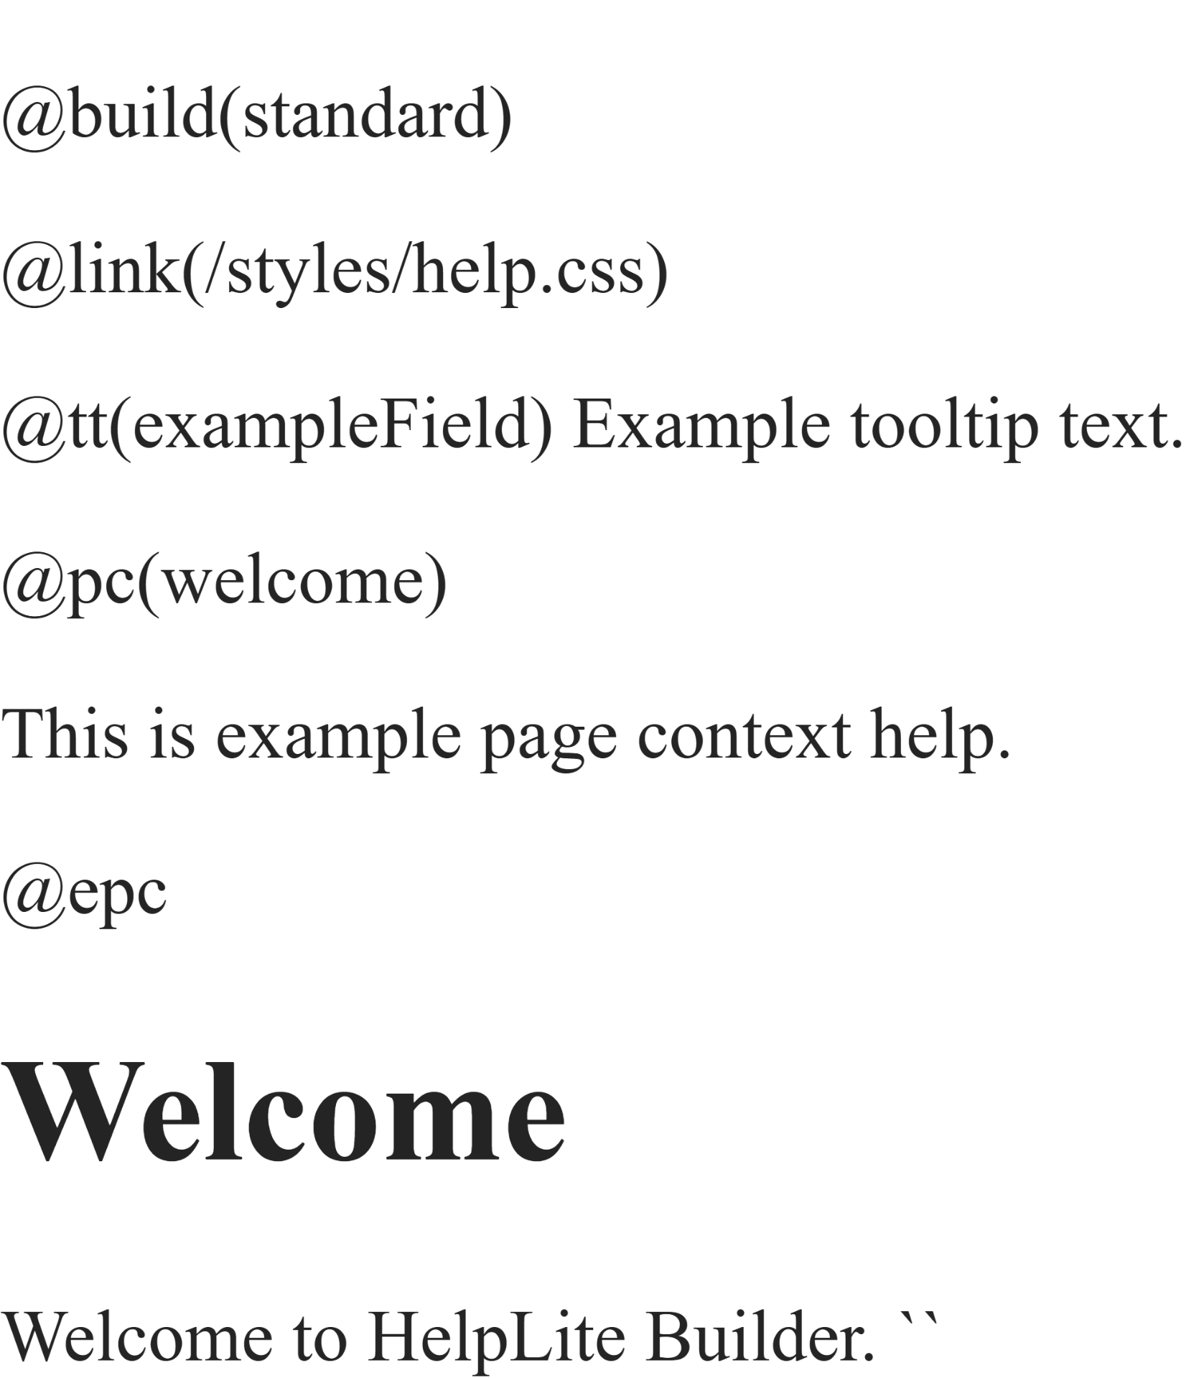
Package Script
If you're using TypeScript with tsx:
{
"scripts": {
"build-help": "tsx src/build.ts"
}
}
Then run:
npm run build-help
Expected output:
[INFO] Looking for: C:\projects\helplite-builder\help\help.md
[INFO] File loaded successfully.
[INFO] Size: 245 characters

--- FIRST 10 LINES ---

1: @build(standard)
2:
3: @link(/styles/help.css)
4:
5: @tt(exampleField)
6: Example tooltip text.
7:
8: @pc(welcome)
9:
10: This is example page context help.

--- END PREVIEW ---
Once that works, your next step is extracting:
@build()
and printing:
Build Type: standard
before moving on to tooltips and page context blocks. One small victory at a time. 🚀
well ... that was unexpected. the npm run throws a ​‌
'tsx' is not recognized as an internal or external command,
operable program or batch file.​‌

and I'm not sure I can actually install anything here. they have a lot of things locked down like downloads
That error usually means one of two things:
- tsx is not installed.
- It's installed locally but not available in the script path.
But since you're trying to keep HelpLite Builder as lightweight as possible, you may not need tsx at all right now.
Check What You're Actually Running
What's in your package.json script?
For example:
{
"scripts": {
"build-help": "tsx src/build.ts"
}
}
If that's what you have, Windows is literally trying to find an executable named:
tsx
and can't.

Quickest Test
Instead of TypeScript, create:
src/build.js
with:
const fs = require("fs");
const path = require("path");

const helpFile = path.join(process.cwd(), "help", "help.md");

console.log("[INFO] Looking for:", helpFile);

if (!fs.existsSync(helpFile)) {
console.error("[ERROR] help.md not found.");
process.exit(1);
}

const content = fs.readFileSync(helpFile, "utf8");

console.log("[INFO] File loaded successfully.");

console.log("\n--- FIRST 10 LINES ---\n");

content
.split("\n")
.slice(0, 10)
.forEach((line, i) => {
console.log(${i + 1}: ${line});
});
Then in package.json:
{
"scripts": {
"build-help": "node src/build.js"
}
}
Run:
npm run build-help
No extra packages required.

If You Want To Stay In TypeScript
Check whether you already have:
npm list tsx
or
npm list typescript
If not, and your environment doesn't allow downloads, you're probably better off prototyping Builder in plain Node.js first.
Honestly, for HelpLite Builder, I'd build the parser in:
Node.js
first anyway.
The logic is:
Read File
Parse Tags
Generate Files
TypeScript doesn't really buy you much until the project gets larger.

My Recommendation
For tonight:
✅ Switch to build.js
✅ Run with node
✅ Prove you can read help.md
✅ Print the first 10 lines
Once that's working, we move on to:
@build()
parsing.
No dependencies. No installs. No fighting your locked-down environment. Just prove the file-reading pipeline works first. 😄🚀
ok - that runs now ... so let's stay in js for now then. let's build the next part.
Perfect. Let's keep it incremental like we did with PrefKeeper.
You already have:
✅ Read file
✅ Display first 10 lines
Now let's extract the first directive:
@build(standard)
and prove we can parse it.
Update build.js
const fs = require("fs");
const path = require("path");

const helpFile = path.join(process.cwd(), "help", "help.md");

console.log("[INFO] Looking for:", helpFile);

if (!fs.existsSync(helpFile)) {
console.error("[ERROR] help.md not found.");
process.exit(1);
}

const content = fs.readFileSync(helpFile, "utf8");

console.log("[INFO] File loaded successfully.");
console.log("[INFO] Size:", content.length, "characters");

// Look for @build(...)
const buildMatch = content.match(/@build$\left(.*?\right)$/);

if (buildMatch) {
const buildType = buildMatch[1].trim();

console.log("\n[INFO] Build type found:");
console.log(" ", buildType);
} else {
console.log("\n[WARN] No @build() directive found.");
}

console.log("\n--- FIRST 10 LINES ---\n");

content
.split("\n")
.slice(0, 10)
.forEach((line, index) => {
console.log(${index + 1}: ${line});
});

console.log("\n--- END PREVIEW ---");

Test File
@build(standard)

@link(/styles/help.css)

# Welcome

Welcome to HelpLite Builder.
Expected output:
[INFO] Looking for: D:\Projects\helplite-builder\help\help.md

[INFO] File loaded successfully.

[INFO] Build type found:
standard

--- FIRST 10 LINES ---

1: @build(standard)
2:
3: @link(/styles/help.css)
4:
5: # Welcome
6:
7: Welcome to HelpLite Builder.
`

Next Step After This
Once this works, I'd extract:
@link(...)
the same way:
const cssMatch = content.match(/@link$\left(.*?\right)$/);
and print:
CSS File: /styles/help.css
After that we'll build:
@tt(name)
text
which is the first directive that actually starts generating output.
So the roadmap becomes:
✅ Read file
✅ Read build type
🔲 Read CSS link
🔲 Extract tooltips
🔲 Extract page context
🔲 Generate tooltips.json
🔲 Generate pagecontext files
🔲 Generate help.html
Small wins. One parser at a time. 🚀
Perfect. Let's keep building the parser.
You already have:
✅ Read file
✅ Parse @build()
Now let's add:
✅ Parse @link()
``

Updated build.js
Add this immediately after the @build() section:
// Look for @link(...)
const linkMatch = content.match(/@link$\left(.*?\right)$/);

if (linkMatch) {
const cssPath = linkMatch[1].trim();

console.log("\n[INFO] CSS link found:");
console.log(" ", cssPath);
} else {
console.log("\n[INFO] No @link() directive found.");
}

Full Example Input
@build(standard)

@link(/styles/help.css)

# Welcome

Welcome to HelpLite Builder.

Expected Output
[INFO] Looking for: D:\Projects\helplite-builder\help\help.md

[INFO] File loaded successfully.
[INFO] Size: 85 characters

[INFO] Build type found:
standard

[INFO] CSS link found:
/styles/help.css

--- FIRST 10 LINES ---

1: @build(standard)
2:
3: @link(/styles/help.css)
4:
5: # Welcome
6:
7: Welcome to HelpLite Builder.

Slight Refactor
Since we're going to need these values later, let's start storing them in an object.
const parsed = {
buildType: "standard",
cssPath: null,
tooltips: {},
pageContexts: {}
};
``
Then:
if (buildMatch) {
parsed.buildType = buildMatch[1].trim();
}
and
if (linkMatch) {
parsed.cssPath = linkMatch[1].trim();
}
`
Then print:
console.log("\n=== PARSED DATA ===");
console.log(parsed);
Expected output:
=== PARSED DATA ===

{
buildType: 'standard',
cssPath: '/styles/help.css',
tooltips: {},
pageContexts: {}
}

Next Step
After this works, we'll tackle:
@tt(receiptAmount)
Total amount shown on the receipt.
because that's the first directive that requires walking the file line-by-line rather than using a simple regex search.
That will get us to our first real output:
{
"receiptAmount": "Total amount shown on the receipt."
}
``
which is the beginning of tooltips.json. 🚀
oK - but, if we are going to go line by line then I would suggest looking for all codes at once and if they meet any of our code values, handling each one at that time or storing their information so we don't run thru this file 10000 times ...we run thru it just once looking for our codes.​‌

but, if we are going to do that, then we should also take a loot at the markdown codes and parsing them out at all since we'll need to turn them into actual html codes, right?​‌

but for now, we can look for 1 code at a time and then build up from there
You're already thinking like a parser author now. 😄
And yes, long term, I would absolutely do one pass through the file.
The eventual architecture probably looks something like:
Read File
↓
Split Into Lines
↓
For Each Line
↓
@build()
@link()
@tt()
@pc()
@epc
Markdown
↓
Store Results
↓
Generate Outputs
instead of:
Regex File
Regex File Again
Regex File Again
Regex File Again
Regex File Again
...
For a help file of 100 lines, it doesn't matter. For a help file of 5,000 lines, it starts to matter.

But I would NOT parse Markdown yet
This is where I think we can save ourselves some pain.
Your builder's responsibilities are:
Extract Directives
Generate Assets
The question becomes:
Do we want to write a Markdown parser?
My answer:
NOOOOOOOOOOOO
🤣
There are already excellent markdown libraries.
Eventually we'll want something like:
const { marked } = require("marked");
or similar.
Then:
html = marked(markdownText);
Done.
Let somebody else spend ten years solving Markdown edge cases.

What I'd Do Next
I'd actually start transitioning toward the final parser structure now.
Something like:
const lines = content.split("\n");

const parsed = {
buildType: "standard",
cssPath: null,
tooltips: {},
pageContexts: {},
markdownLines: []
};
Then:
for (let i = 0; i < lines.length; i++) {
const line = lines[i].trim();

// build
if (line.startsWith("@build(")) {
...
continue;
}

// link
if (line.startsWith("@link(")) {
...
continue;
}

// everything else
}
We're not even generating files yet.
We're proving we can:
Read
Detect
Store

Then Tooltips
Later:
@tt(receiptAmount)
Total receipt amount.
becomes:
parsed.tooltips["receiptAmount"] =
"Total receipt amount.";

Then Page Context
@pc(receipts)

Stuff

Stuff

@epc
gets collected into:
parsed.pageContexts["receipts"] =
</span><br></div><div><span attribution="{&quot;id&quot;:&quot;E64C3D4F-5E12-4514-AD9B-893A6FAFD00C&quot;,&quot;name&quot;:&quot;Copilot&quot;,&quot;oid&quot;:&quot;E64C3D4F-5E12-4514-AD9B-893A6FAFD00C&quot;,&quot;timestamp&quot;:1789411500000,&quot;dataSource&quot;:0}">Stuff</span><br></div><div><span></span><br></div><div><span attribution="{&quot;id&quot;:&quot;E64C3D4F-5E12-4514-AD9B-893A6FAFD00C&quot;,&quot;name&quot;:&quot;Copilot&quot;,&quot;oid&quot;:&quot;E64C3D4F-5E12-4514-AD9B-893A6FAFD00C&quot;,&quot;timestamp&quot;:1789411500000,&quot;dataSource&quot;:0}">Stuff</span><br></div><div><span attribution="{&quot;id&quot;:&quot;E64C3D4F-5E12-4514-AD9B-893A6FAFD00C&quot;,&quot;name&quot;:&quot;Copilot&quot;,&quot;oid&quot;:&quot;E64C3D4F-5E12-4514-AD9B-893A6FAFD00C&quot;,&quot;timestamp&quot;:1789411500000,&quot;dataSource&quot;:0}">;
``

Then Markdown
Everything that isn't:
@build()
@link()
@tt()
@pc()
@epc
gets pushed into:
parsed.markdownLines.push(line);
`
so later you'll have:
const markdown =
parsed.markdownLines.join("\n");
ready for conversion.

Why I Like This
Because eventually:
help.md
↓
Single Pass Parser
↓
Parsed Object
↓
HTML Generator
TXT Generator
JSON Generator
The parser only has one job:
Understand the file.
The generators only have one job:
Create output.
Very clean.

So I'd suggest:
Phase 1
✅ Read file
✅ Parse @build()
✅ Parse @link()
Phase 2
✅ Convert to single-pass parser
✅ Parse @tt()
✅ Parse @pc() / @epc
✅ Collect markdown
Phase 3
✅ Write tooltips.json
✅ Write pagecontext/*.txt
Phase 4
✅ Markdown → HTML
✅ Generate help.html
At that point you'll have a working HelpLite Builder MVP.
And yes, your instinct is correct: we're eventually going to want a single-pass parser rather than repeatedly searching the file. That's a much cleaner foundation to build on. 🚀
ohhhh .. there is a npm module for markdown already .... GREAT!!!! solves that problem :)​‌

and it has a custom parser as well . shit that's got a lot of downloads. but, it's not standard markdown code though ... it's using "=" and "-" for headings ... I mean, not a big deal, we can go that way ... and would need to look into this a bit more .. but if there's a fast, widely used parser already, yeah, changing to its format is the smarter thing to do. and it's MIT which fits in with the PK and HP license​‌

and now, after taking a little break, I'll question why are we doing this this way? it's seems .. burdensome ... both to our code and the developer.​‌
think about this: the developer is writing their help instructions and has to pause every now and then to write in our markup codes for tt and context and then go back their help lines .. and then curse us out because they type duplicate tt's and messed up this help (not that we can't check for duplicates, which we should anyways) but why make the developer scroll all up and down looking to see if they used the same name twice​‌

would it not be easier for us to parse and more elegant for them to use if all the tt's where in a group section at the top of the markdown in a "@tt" and "@ett" section with a rule of one line per tt item, all the context was in a "@pc" and "@epc" with each line for pc being literally "{name of page}": text this way we could use the {} to denote when a new items starts and ends ... and then everything else after the "#epc" is the global md to parse
I actually think you've just improved the design significantly.
What you're realizing is:
We're treating the help file like source code.
But the developer is treating it like documentation.
Those are two very different mindsets.

Current Idea
# Receipts

Some help text.

@tt(receiptAmount)
Amount shown on receipt.

More help text.

@tt(receiptVendor)
Vendor name.

Even more help text.

@pc(receipts)

Page context...

@epc
`
Problems
- Directives scattered everywhere.
- Easy to create duplicates.
- Hard to scan.
- Hard to validate.
- Hard to maintain.
As the help file grows:
Help
Directive
Help
Directive
Help
Directive
becomes annoying.

Your New Idea
Something like:
@tt

{receiptAmount}
Amount shown on receipt.

{receiptVendor}
Vendor name shown on receipt.

{businessName}
Legal business name.

@ett

@pc

{receipts}
Store receipts for bookkeeping.

{newbusiness}
Create your business before adding records.

@epc

# Receipts

All normal markdown from here down.

## Uploading

Help text...

## Categorizing

Help text...
That's actually much cleaner.

Why I Like It
The developer now thinks in sections:
Tooltips
@tt
...
@ett
Page Context
@pc
...
@epc
Global Help
# Everything Else

No jumping around.
No hunting.
No mixing concerns.

Parsing Becomes Easier Too
Builder logic becomes:
Read file
↓
Inside @tt block?
↓
Store tooltips

Inside @pc block?
↓
Store page contexts

Everything else?
↓
Markdown
`
Very straightforward.

I Might Tweak The Syntax Slightly
Instead of:
{receiptAmount}
Amount shown on receipt.
I might do:
receiptAmount:
Amount shown on receipt.
or
receiptAmount | Amount shown on receipt.
because it's easier to parse.
But honestly your {} idea is fine too.
Example:
@tt

{receiptAmount}
Amount shown on receipt.

{receiptVendor}
Vendor name shown on receipt.

@ett
Builder sees:
{}
and knows a new item begins.
Simple enough.

Page Context
Same idea:
@pc

{receipts}
Store receipts for bookkeeping and taxes.

{newbusiness}
Create your business before adding contacts,
documents, or receipts.

@epc
Output:
pagecontext/
├── receipts.txt
└── newbusiness.txt

Then Markdown Becomes Pure Markdown
This is my favorite part.
After:
@epc
everything is just:
# Receipts

## Uploading

## Categorizing

## Reports
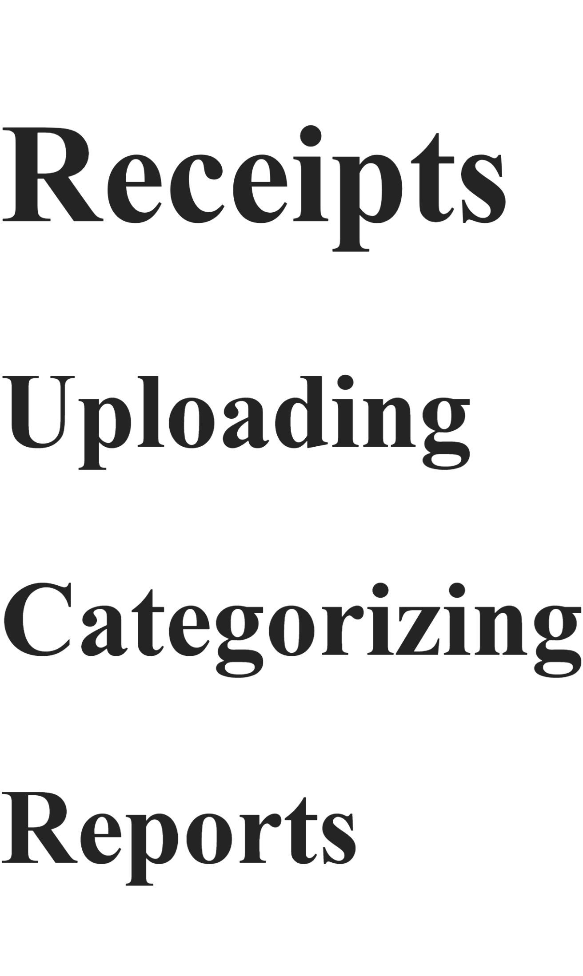
No custom directives mixed into the document itself.
No interruptions.
No weird syntax every few paragraphs.

Even Better...
Now the builder can validate.
Example:
Duplicate tooltip:
{receiptAmount}
Builder output:
ERROR:
Duplicate tooltip ID "receiptAmount"
Very easy.
Same for page context:
Duplicate page context "receipts"
Easy to detect.

As For Markdown
I completely agree with you.
If there's a mature MIT-licensed parser:
Don't write your own.
😄
Use theirs.
Your value is:
HelpLite directives
`
not:
Competing with Markdown parsers.
Let the community-maintained package handle:
- headings
- lists
- tables
- code blocks
- links
and focus on:
- tooltips
- page context
- help generation

Honestly, I think you've just moved from:
"embedded directives in a document"
to
"structured sections with clear responsibilities"
And I think the second approach is going to be much easier both for you and for future developers using HelpLite Builder. I'd strongly consider freezing the syntax around this idea before writing much more parser code. It feels substantially cleaner than sprinkling directives throughout the markdown. 🚀
So, I was thinking more like this format - no spaces between items

but, there is a concern for page context items which might have 2 or more lines in them. unless we add something inline that would tell us to break ... which could literally be <br /> which the browser should interpret as a carriage return ... right?

@tt
receiptAmount | Amount shown on receipt.
receiptVendor | Vendor name shown on receipt.
businessName | Legal business name.
@ett

@pc
receipts | Store receipts for bookkeeping.
newbusiness | Create your business before adding records.
But this is a new line in the page context.
@epc

# Receipts

All normal markdown from here down.

## Uploading

Help text...

## Categorizing

Help text...
I actually like this format a lot better.
It's becoming:
Metadata Section
↓
Tooltips

Metadata Section
↓
Page Context

Markdown Section
↓
Global Help
which is easy for a human to scan.

Tooltips
This looks good:
@tt
receiptAmount | Amount shown on receipt.
receiptVendor | Vendor name shown on receipt.
businessName | Legal business name.
@ett
Parser logic becomes:
const [name, value] = line.split("|");
Then store:
{
"receiptAmount": "Amount shown on receipt.",
"receiptVendor": "Vendor name shown on receipt.",
"businessName": "Legal business name."
}
Simple.

Page Context
This is where I see a problem:
@pc
receipts | Store receipts for bookkeeping.
newbusiness | Create your business before adding records.
But this is a new line in the page context.
@epc
How does the parser know whether:
But this is a new line...
belongs to:
receipts
or
newbusiness
?
It doesn't.

Option 1 - HTML Breaks
You suggested:
newbusiness | Create your business before adding records.<br />
But this is a new line in the page context.
That will work.
The browser will render:

as a line break.
But now developers are writing HTML inside a text file.
Not terrible, but not ideal.

Option 2 - Continuation Lines (My Favorite)
Example:
@pc
receipts | Store receipts for bookkeeping.

newbusiness | Create your business before adding records.
This is a second line.
This is a third line.

@epc
Rule:
- A line containing | starts a new item.
- Indented lines belong to the previously defined item.
Parser stores:
{
"newbusiness": "Create your business before adding records.\nThis is a second line.\nThis is a third line."
}
This feels more natural.

Option 3 - Explicit Block Syntax
@pc

[newbusiness]

Create your business before adding records.

This is another line.

[/newbusiness]

@epc
Very clear.
Very easy to parse.
But more typing.
Which you're trying to avoid.

My Vote
For HelpLite, I'd use:
@pc
receipts | Store receipts for bookkeeping.

newbusiness | Create your business before adding records.
This is a second line.
This is a third line.
@epc
because:
✅ Minimal typing
✅ Human readable
✅ No HTML required
✅ Easy parser
✅ Supports multi-line help

One More Thought
You might want to make comments available from day one:
// Tooltip Help

@tt
receiptAmount | Amount shown on receipt.
receiptVendor | Vendor name shown on receipt.
@ett
Builder ignores:
//
That makes large help files easier to organize.

The Markdown Section
I really like that everything after:
@epc
is just normal markdown.
Example:
# Receipts

All normal markdown from here down.

## Uploading

Help text...

## Categorizing

Help text...
Now developers can focus on writing documentation instead of mixing directives throughout the document.
Honestly, I think you've evolved the format quite a bit in the last hour. The original scattered @tt() directives would work, but this block-based approach is much cleaner and will be much easier to maintain in a 50+ page help system like CorpKeeper's. 🚀
Yeah, let's go with option 2 for the page context - we would just need to make sure our code trims out any whitespace or tabs, which should be easy to handle.​‌

yeah, let's use the comment idea too so we can provide instructions like "don't bloody edit this line" :)​‌

yeah, that's what I was thinking ... after all , the idea for this is for solo builders to be able to quickly build a help file ... not do more.​‌

so let's see about rebuilding the parsers for this and building out a new example file to use.
I think we've got a much cleaner format now.
The biggest win is that we've separated:
Configuration
Tooltips
Page Context
Markdown Help
into distinct sections instead of intermixing everything.

Proposed Help File
// Build type for HelpLite
@build(standard)

// Optional CSS file to include
@link(/styles/help.css)

// Tooltip Definitions
@tt

receiptAmount | Amount shown on receipt.
receiptVendor | Vendor name shown on receipt.
businessName | Legal business name.

@ett

// Page Context Help
@pc

receipts | Store receipts for bookkeeping.

newbusiness | Create your business before adding records.
This is a second line.
This is a third line.

contacts | Store your professional contacts.

@epc

# Receipts

All normal markdown from here down.

## Uploading

Help text...

## Categorizing

Help text...

Expected Parse Result
{
buildType: "standard",

cssPath: "/styles/help.css",

tooltips: {
receiptAmount: "Amount shown on receipt.",
receiptVendor: "Vendor name shown on receipt.",
businessName: "Legal business name."
},

pageContexts: {
receipts: "Store receipts for bookkeeping.",

newbusiness:
"Create your business before adding records.\n" +
"This is a second line.\n" +
"This is a third line.",

contacts:
"Store your professional contacts."
},

markdown: </span><br></div><div><span attribution="{&quot;id&quot;:&quot;E64C3D4F-5E12-4514-AD9B-893A6FAFD00C&quot;,&quot;name&quot;:&quot;Copilot&quot;,&quot;oid&quot;:&quot;E64C3D4F-5E12-4514-AD9B-893A6FAFD00C&quot;,&quot;timestamp&quot;:1789414800000,&quot;dataSource&quot;:0}"># Receipts</span><br></div><div><span></span><br></div><div><span attribution="{&quot;id&quot;:&quot;E64C3D4F-5E12-4514-AD9B-893A6FAFD00C&quot;,&quot;name&quot;:&quot;Copilot&quot;,&quot;oid&quot;:&quot;E64C3D4F-5E12-4514-AD9B-893A6FAFD00C&quot;,&quot;timestamp&quot;:1789414800000,&quot;dataSource&quot;:0}">All normal markdown from here down.</span><br></div><div><span></span><br></div><div><span attribution="{&quot;id&quot;:&quot;E64C3D4F-5E12-4514-AD9B-893A6FAFD00C&quot;,&quot;name&quot;:&quot;Copilot&quot;,&quot;oid&quot;:&quot;E64C3D4F-5E12-4514-AD9B-893A6FAFD00C&quot;,&quot;timestamp&quot;:1789414800000,&quot;dataSource&quot;:0}">## Uploading</span><br></div><div><span></span><br></div><div><span attribution="{&quot;id&quot;:&quot;E64C3D4F-5E12-4514-AD9B-893A6FAFD00C&quot;,&quot;name&quot;:&quot;Copilot&quot;,&quot;oid&quot;:&quot;E64C3D4F-5E12-4514-AD9B-893A6FAFD00C&quot;,&quot;timestamp&quot;:1789414800000,&quot;dataSource&quot;:0}">Help text...</span><br></div><div><span></span><br></div><div><span attribution="{&quot;id&quot;:&quot;E64C3D4F-5E12-4514-AD9B-893A6FAFD00C&quot;,&quot;name&quot;:&quot;Copilot&quot;,&quot;oid&quot;:&quot;E64C3D4F-5E12-4514-AD9B-893A6FAFD00C&quot;,&quot;timestamp&quot;:1789414800000,&quot;dataSource&quot;:0}">## Categorizing</span><br></div><div><span></span><br></div><div><span attribution="{&quot;id&quot;:&quot;E64C3D4F-5E12-4514-AD9B-893A6FAFD00C&quot;,&quot;name&quot;:&quot;Copilot&quot;,&quot;oid&quot;:&quot;E64C3D4F-5E12-4514-AD9B-893A6FAFD00C&quot;,&quot;timestamp&quot;:1789414800000,&quot;dataSource&quot;:0}">Help text...</span><br></div><div><span attribution="{&quot;id&quot;:&quot;E64C3D4F-5E12-4514-AD9B-893A6FAFD00C&quot;,&quot;name&quot;:&quot;Copilot&quot;,&quot;oid&quot;:&quot;E64C3D4F-5E12-4514-AD9B-893A6FAFD00C&quot;,&quot;timestamp&quot;:1789414800000,&quot;dataSource&quot;:0}">
}

New Parser Strategy
Instead of:
Regex
Regex
Regex
Regex
let's move to:
Read File
↓
Split Into Lines
↓
Single Pass Through File
and track where we are.
let mode = "markdown";
Possible modes:
"normal"
"tooltips"
"pagecontext"

Pseudo Code
for each line

remove leading/trailing whitespace

if comment
skip

if @build(...)
store build type

if @link(...)
store css path

if @tt
mode = tooltips

if @ett
mode = normal

if @pc
mode = pagecontext

if @epc
mode = normal

if mode == tooltips
parse tooltip

if mode == pagecontext
parse context

else
store markdown

Tooltip Parser
Input:
receiptAmount | Amount shown on receipt.
Output:
tooltips["receiptAmount"] =
"Amount shown on receipt.";
And we can detect duplicates:
if (tooltips[name]) {
throw Error(
Duplicate tooltip: ${name}
);
}

Page Context Parser
Input:
newbusiness | Create your business before adding records.
starts a new context.
Then:
This is a second line.
becomes an appended line.
Result:
pageContexts["newbusiness"] =
"Create your business before adding records.\n" +
"This is a second line.";
Easy to understand.
Easy to maintain.

Comments
I like:
// comments
because they're obvious.
Parser simply does:
if (line.startsWith("//"))
{
continue;
}

Output Structure
Still:
help.md
↓
HelpLite Builder
├── help.html
├── pagecontext/
│ ├── receipts.txt
│ ├── newbusiness.txt
│ └── contacts.txt
│
└── input/
└── tooltips.json

Next Coding Milestone
I'd build the parser in this order:
✅ Read file
✅ Parse @build
✅ Parse @link

🔲 Parse comments

🔲 Parse @tt / @ett

🔲 Parse @pc / @epc

🔲 Collect markdown

🔲 Display parsed object

🔲 Generate tooltips.json

🔲 Generate pagecontext files

🔲 Generate help.html
At that point you'll have the core HelpLite Builder engine working, and the developer experience stays very simple:
Write one help file
↓
Run npm build
↓
Everything generated
which is exactly the goal you set out with. 🚀
question: for the each line psuedo code (and actual code), which would run faster? a bunch of if/thens, a case select structure or mapping?​‌

and while we are at it. should we really be adding "\n" to the context text? Will a browser interpret that as a new line??? and what about "\n\n" for a double, new line?
1. if/else vs switch vs mapping
For what HelpLite Builder is doing?
It doesn't matter enough to optimize for performance.
You'll be parsing maybe:
100 lines
500 lines
1000 lines
once during a build.
The bottleneck will be file I/O and markdown generation, not checking directives.
I'd optimize for readability.

Option A: Sequential ifs
if (line === "@tt") {
mode = "tooltips";
continue;
}

if (line === "@ett") {
mode = "normal";
continue;
}

if (line === "@pc") {
mode = "pagecontext";
continue;
}
✅ Easy to understand
✅ Easy to debug
✅ Easy to extend
For V1, this is probably what I'd use.

Option B: switch
switch (line) {
case "@tt":
mode = "tooltips";
break;

case "@ett":
mode = "normal";
break;

case "@pc":
mode = "pagecontext";
break;
}
✅ Clean if all commands are exact matches
❌ Doesn't help with:
@build(standard)
@link(...)
because those need parsing.

Option C: Mapping
Eventually:
const commands = {
"@tt": () => mode = "tooltips",
"@ett": () => mode = "normal",
"@pc": () => mode = "pagecontext",
"@epc": () => mode = "normal"
};
Then:
if (commands[line]) {
commandsline;
}
✅ Most extensible
✅ Nice for v2/v3
❌ Extra complexity today

My Vote
For V1:
if/else
Then later, if commands start growing:
mapping

2. Should Page Context Use \n?
This is the more important question.
Browser Behavior
If you put:

inside HTML, the browser renders:
Hello World
because HTML collapses whitespace.

Example
const text = "Hello\nWorld";
Inserted into:

renders as:
Hello World
``
not:
Hello
World

Option A: Store \n
Store:
context += "\n" + line;
Output:
Line 1
Line 2
Line 3
``
Then HelpLite converts:
text.replace(/\n/g, "<br>")
when displaying.
This is what I would do.
Store raw text.
Render later.

Option B: Store <br>
Builder generates:
Line 1<br>
Line 2<br>
Line 3
directly.
This works...
but now you're mixing presentation into the data.
I'm not a fan of that.

Option C: Array Of Lines
Honestly, this is my favorite.
Builder stores:
pageContexts["newbusiness"] = [
"Create your business before adding records.",
"This is a second line.",
"This is a third line."
];
Then HelpLite decides how to render it:
lines.join("<br>")
or
lines.join("\n")
``
or
<p>...</p>
Very flexible.

What About Double Line Breaks?
If the help file contains:
newbusiness | Create your business before adding records.

This starts a new paragraph.
you could store:
[
"Create your business before adding records.",
"",
"This starts a new paragraph."
]
Then render:
join("<br>")
producing:
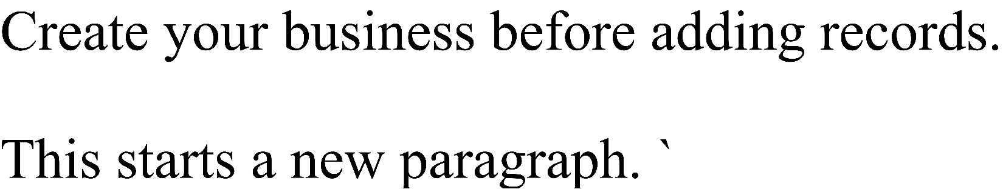
which visually creates a blank line.

What I'd Do
For the parser:
pageContexts = {
newbusiness: [
"Create your business before adding records.",
"This is a second line.",
"This is a third line."
]
};
Then when writing:
Create your business before adding records.
This is a second line.
This is a third line.
or when displaying in HelpLite:
contextLines.join("<br>")
Keeping data and presentation separate usually pays off later.
And for the parser itself?
Go with boring old if statements for now. We're talking milliseconds during a build process, but you'll read and modify that code dozens of times while developing HelpLite Builder. Readability wins here. 😄🚀
Yeah, I think this is the better choice:​‌
[
"Create your business before adding records.",
"",
"This starts a new paragraph."
]​‌

ok let's rebuild using these decisions then
Yep. I think we've now got a much cleaner model:
Tooltips
@tt

receiptAmount | Amount shown on receipt.
receiptVendor | Vendor name shown on receipt.
businessName | Legal business name.

@ett
Stored as:
tooltips = {
receiptAmount: "Amount shown on receipt.",
receiptVendor: "Vendor name shown on receipt.",
businessName: "Legal business name."
};

Page Context
@pc

receipts | Store receipts for bookkeeping.

newbusiness | Create your business before adding records.
This is a second line.

This starts a new paragraph.

@epc
Stored as:
pageContexts = {
receipts: [
"Store receipts for bookkeeping."
],

newbusiness: [
"Create your business before adding records.",
"This is a second line.",
"",
"This starts a new paragraph."
]
};
Which is much nicer than constantly worrying about:
"\n"
"<br>"
"\n\n"
That's HelpLite's problem later. Builder should just preserve structure.

Updated Parsed Object
const parsed = {
buildType: "standard",
cssPath: null,

tooltips: {},

pageContexts: {},

markdownLines: []
};

New Parser Skeleton
const fs = require("fs");
const path = require("path");

const helpFile = path.join(process.cwd(), "help", "help.md");

const content = fs.readFileSync(helpFile, "utf8");

const lines = content.split("\n");

const parsed = {
buildType: "standard",
cssPath: null,
tooltips: {},
pageContexts: {},
markdownLines: []
};

let mode = "normal";

let currentContext = null;

for (let rawLine of lines) {

const line = rawLine.trim();

// Ignore comments
if (line.startsWith("//")) {
continue;
}

// Build type
if (line.startsWith("@build(")) {
parsed.buildType = line
.replace("@build(", "")
.replace(")", "")
.trim();

continue;
}

// CSS Link
if (line.startsWith("@link(")) {
parsed.cssPath = line
.replace("@link(", "")
.replace(")", "")
.trim();

continue;
}

// Tooltip Start
if (line === "@tt") {
mode = "tooltip";
continue;
}

// Tooltip End
if (line === "@ett") {
mode = "normal";
continue;
}

// Page Context Start
if (line === "@pc") {
mode = "pagecontext";
continue;
}

// Page Context End
if (line === "@epc") {
mode = "normal";
currentContext = null;
continue;
}

// TOOLTIPS
if (mode === "tooltip") {

if (!line) continue;

const parts = line.split("|");

if (parts.length < 2) continue;

const name = parts[0].trim();
const text = parts.slice(1).join("|").trim();

parsed.tooltips[name] = text;

continue;
}

// PAGE CONTEXT
if (mode === "pagecontext") {

if (!line) {

if (currentContext) {
parsed.pageContexts[currentContext].push("");
}

continue;
}

if (line.includes("|")) {

const parts = line.split("|");

const name = parts[0].trim();
const text = parts.slice(1).join("|").trim();

currentContext = name;

parsed.pageContexts[name] = [text];

continue;
}

if (currentContext) {
parsed.pageContexts[currentContext].push(line);
}

continue;
}

// MARKDOWN
parsed.markdownLines.push(rawLine);
}

console.log(JSON.stringify(parsed, null, 2));

Example Output
{
"buildType": "standard",
"cssPath": "/styles/help.css",
"tooltips": {
"receiptAmount": "Amount shown on receipt.",
"receiptVendor": "Vendor name shown on receipt."
},
"pageContexts": {
"receipts": [
"Store receipts for bookkeeping."
],
"newbusiness": [
"Create your business before adding records.",
"This is a second line.",
"",
"This starts a new paragraph."
]
},
"markdownLines": [
"# Receipts",
"",
"All normal markdown from here down."
]
}
That's a pretty solid foundation. Once this works, the next milestone is:
- Detect duplicate tooltip names.
- Detect duplicate page context names.
- Write tooltips.json.
- Write pagecontext/*.txt.
Only after that would I pull in the markdown parser and generate help.html. That keeps us proving each piece before adding more moving parts. 🚀
OK - just an odd thing that we are getting \r with all of the markdown​‌

> build-help
> node src/build.js

{
"buildType": "standard",
"cssPath": "/styles/help.css",
"tooltips": {
"receiptAmount": "Amount shown on receipt.",
"receiptVendor": "Vendor name shown on receipt.",
"businessName": "Legal business name."
},
"pageContexts": {
"receipts": [
"Store receipts for bookkeeping."
],
"newbusiness": [
"Create your business before adding records.",
"This is a second line.",
"This is a third line."
],
"contacts": [
"Store your professional contacts."
]
},
"markdownLines": [
"\r",
"\r",
"\r",
"\r",
"# New Business\r",
"\r",
"The New Business page is used to create and manage\r",
"your business profile.\r",
"\r",
"## Business Information\r",
"\r",
"Enter the legal name of your business along with\r",
"its entity type.\r",
"\r",
"## Tax Information\r",
"\r",
"Store your EIN and accounting preferences here.\r",
"\r",
"## Next Steps\r",
"\r",
"After creating a business profile you should:\r",
"\r",
"- Add professional contacts\r",
"- Upload important documents\r",
"- Configure notifications\r",
"\r",
"# Receipts\r",
"\r",
"## Uploading Receipts\r",
"\r",
"Take a clear photo of the receipt and verify the\r",
"important details are visible.\r",
"\r",
"## Categorizing Receipts\r",
"\r",
"Assign appropriate categories so reports remain accurate.\r",
"\r",
"## Reporting\r",
"\r",
"Categorized receipts will become available in\r",
"financial reports and exports."
]
}​‌

Yep. That's just Windows line endings showing up.
You're doing:
const lines = content.split("\n");
But Windows files are usually:
\r\n
not:
\n
So when you split on \n, the \r gets left behind.
Example:
# New Business\r\n
becomes:
"# New Business\r"
after the split.

Easy Fix
Change:
const lines = content.split("\n");
to:
const lines = content.split(/\r?\n/);
Now it handles both:
Windows -> \r\n
Linux -> \n
Mac -> \n
and removes the issue everywhere.

Alternative
You could sanitize the file first:
const content = fs
.readFileSync(helpFile, "utf8")
.replace(/\r/g, "");
``
Then:
const lines = content.split("\n");
works cleanly.

What I'd Do
Personally:
const lines = content.split(/\r?\n/);
because it's the standard solution.

Another Improvement
Your markdown output currently starts with:
"markdownLines": [
"",
"",
"",
"",
"# New Business",
...
]
because you're preserving the blank lines left behind after:
@build()
@link()
@tt
...
@ett
@pc
...
@epc
That's actually fine right now.
Later, when generating help.html, you'll simply do:
const markdown =
parsed.markdownLines.join("\n");
and pass that to the markdown parser.
Markdown ignores extra blank lines anyway.

More Important Observation
The parser appears to be working correctly.
You successfully extracted:
✅ Build type
✅ CSS path
✅ Tooltips
✅ Page contexts
✅ Markdown body
That's actually the first major milestone of HelpLite Builder.
At this point I'd make a git commit like:
feat(builder): parse help source file
before moving on.
Next up I'd probably do:
Generate tooltips.json
``
because that's the easiest output file and will prove the write process works before we tackle HTML generation. 🚀
so, I'm going to say at this point, it looks like we still want the 3 write files even though the markdown module will do the global build ... but do we need the parser folder anymore and the 4 files in it? they don't really seem like they will do anything now as the build is pulling everything out. and we won't need the types.ts file either. is that about correct? or are these still needed?
I think you're right.
What happened over the last hour is that the architecture got simpler.
Originally we were thinking:
build.ts
↓
parseBuild.ts
parseLink.ts
parseTooltips.ts
parsePageContext.ts
↓
types.ts
↓
generators
because we were imagining a much larger system.
Now we have:
build.js
↓
Read File
↓
Single Pass Parse
↓
Parsed Object
↓
Write Outputs
That's a perfectly valid design for a V1.
Do We Need parsers/?
Right Now?
No.
Not unless you're trying to keep the code organized from the start.
The parser is currently:
for (let rawLine of lines)
{
...
}
inside one file.
That's fine.

Future?
Maybe.
If build.js grows from:
100 lines
to
1000 lines
then I'd split it up.
Something like:
src/
├── build.js
├── parse.js
├── writeTooltips.js
├── writeContexts.js
└── writeHtml.js
But we're not there yet.

Do We Need types.ts?
No.
That's a TypeScript artifact.
Since we're now running:
node build.js
there's no compiler looking at types.
So:
types.ts
can disappear completely.
If you eventually move to TypeScript, you can bring it back.
For now:
const parsed = {
buildType: "standard",
cssPath: null,
tooltips: {},
pageContexts: {},
markdownLines: []
};
is effectively your type definition.

What Files Do We Actually Need?
Honestly, I'd keep it very small.
src/
└── build.js

help/
└── help.md

package.json

README.md
That's all you need today.

Once We Start Writing Files
Then I'd consider:
src/
├── build.js
├── writeTooltips.js
├── writePageContexts.js
└── writeHtml.js
because writing output is a natural separation point.
Build
Parses.
Writers
Generate files.
Nice separation.

Current MVP Architecture
I'd say we're now aiming for:
help.md
↓
build.js
↓
Parsed Object
├── tooltips.json
├── pagecontext/*.txt
└── help.html
That's it.
No parser folder.
No types.
No renderer.
No abstractions until we actually need them.
One thing I've learned from watching you build PrefKeeper is that you do best when you start simple and only introduce structure when a real problem appears. Right now, those extra files are a solution looking for a problem.
I'd leave everything in build.js, get the three output files generating, and only split things apart once the file starts becoming uncomfortable to work in. 😄🚀
so we have a writers folderr then with writeHtml.js, writePageContext.js and writeTooltips.js so we'll keep that file structure. the new files we write from here should go under help -> help.html for global, help -> pages -> 1 file per page context as a .txt file, help -> fields -> 1 file with .json ​‌

all of these files can then be consumed by HP later on.
Yep, I think that's a much cleaner architecture.
At this point I see the Builder as having two responsibilities:
- Parse the source help file.
- Write the generated HelpLite files.
That's it.
Current Structure
helplite-builder/
│
├── help/
│ └── help.md
│
├── src/
│ ├── build.js
│ │
│ └── writers/
│ ├── writeHtml.js
│ ├── writePageContext.js
│ └── writeTooltips.js
│
├── package.json
└── README.md

Generated Structure
After:
npm run build-help
you get:
help/
│
├── help.md
│
├── help.html
│
├── pages/
│ ├── receipts.txt
│ ├── newbusiness.txt
│ └── contacts.txt
│
└── fields/
└── tooltips.json
And that output structure is actually very nice because HelpLite can consume it directly.
Global Help
help/help.html
Used by:
openGlobalHelp()

Page Context
help/pages/*.txt
Used by:
showPageContext("receipts")
which loads:
help/pages/receipts.txt

Field Help
help/fields/tooltips.json
Used by:
showTooltip("receiptAmount")
which looks up:
{
"receiptAmount": "Amount shown on receipt."
}

Writers
I think these files should each have exactly one job.
writeTooltips.js
Input:
parsed.tooltips
Output:
help/fields/tooltips.json

writePageContext.js
Input:
parsed.pageContexts
Output:
help/pages/*.txt
one file per context.
Example:
help/pages/newbusiness.txt
contents:
Create your business before adding records.
This is a second line.

This starts a new paragraph.

writeHtml.js
Input:
parsed.markdownLines
parsed.cssPath
Output:
help/help.html
Generated via markdown parser.

build.js
Eventually becomes very simple:
Read help.md
↓
Parse help.md
↓
writeTooltips()
writePageContext()
writeHtml()
So:
const parsed = parseHelpFile();

writeTooltips(parsed);
writePageContext(parsed);
writeHtml(parsed);
Very clean.

One Small Suggestion
I would eventually add:
help/generated/
instead of writing beside help.md.
Example:
help/
│
├── help.md
│
└── generated/
├── help.html
├── pages/
└── fields/
Reason:
You never accidentally edit generated files.
Source and output are separated.
But for now?
help/
├── help.md
├── help.html
├── pages/
└── fields/
is perfectly fine and easier to understand while you're building the MVP.
I think you're at the point where the next task is to write writeTooltips.js first. It's the simplest writer, proves file creation works, and gives you your first generated asset. After that, page contexts, then HTML generation last. 🚀
recall that the reason for this file structure is because these generated files will be the files in your project which HP will consume .. so they need to be in the proper folders already. we can move the help.md somewhere else to clear that up if need be.​‌

for now, let's generate the writetooltips
Good point. If these files are the runtime files that HelpLite consumes, then they belong exactly where HP expects them.
I'd actually consider eventually moving the source file here:
help-source/
└── help.md
and generating:
help/
├── help.html
├── pages/
│ ├── receipts.txt
│ ├── newbusiness.txt
│ └── contacts.txt
└── fields/
└── tooltips.json
But that's a future cleanup. For now let's get file generation working.

writeTooltips.js
Create:
src/writers/writeTooltips.js
const fs = require("fs");
const path = require("path");

function writeTooltips(tooltips) {
const outputDir = path.join(
process.cwd(),
"help",
"fields"
);

// Create folder if needed
fs.mkdirSync(outputDir, {
recursive: true
});

const outputFile = path.join(
outputDir,
"tooltips.json"
);

fs.writeFileSync(
outputFile,
JSON.stringify(tooltips, null, 2),
"utf8"
);

console.log(
[INFO] Tooltips written: ${outputFile}
);
}

module.exports = writeTooltips;

Update build.js
Near the top:
const writeTooltips = require(
"./writers/writeTooltips"
);
At the bottom after your:
console.log(JSON.stringify(parsed, null, 2));
add:
writeTooltips(parsed.tooltips);

Expected Output
Input:
@tt

receiptAmount | Amount shown on receipt.
receiptVendor | Vendor name shown on receipt.
businessName | Legal business name.

@ett
Generated file:
help/
└── fields/
└── tooltips.json
Contents:
{
"receiptAmount": "Amount shown on receipt.",
"receiptVendor": "Vendor name shown on receipt.",
"businessName": "Legal business name."
}

Optional Validation
Before writing:
if (
!tooltips ||
Object.keys(tooltips).length === 0
) {
console.warn(
"[WARN] No tooltips found."
);
return;
}
but that's entirely optional for V1.

Success Criteria
When you run:
npm run build-help
you should see:
[INFO] Tooltips written:
C:...\help\fields\tooltips.json
and physically have:
help/fields/tooltips.json
on disk.
That gives us our first generated artifact, which means we've completed the "read → parse → write" pipeline. After that, writePageContext.js is basically the same pattern, just generating multiple files instead of one. 🚀
well .. once we copied the code into the right file (had it in the wrong file initially) and then figured out that our writeTooltips.js was actually writeToottips.js ... we have a file created with the correct informatin :)​‌

but yes, we should validate that we have each item before we attempt to write the file for it. no sense trying if there is nothing there.​‌

so, with that, we can generate the code for the page context now
Perfect. 😄
You just hit the first real milestone:
help.md
↓
Parser
↓
tooltips.json
actually works.
And yes, absolutely validate before writing. If there are no tooltips, don't create:
help/fields/tooltips.json
at all.
That keeps things clean.

writePageContext.js
Create:
src/writers/writePageContext.js
const fs = require("fs");
const path = require("path");

function writePageContext(pageContexts) {

if (
!pageContexts ||
Object.keys(pageContexts).length === 0
) {
console.warn(
"[WARN] No page contexts found."
);

return;
}

const outputDir = path.join(
process.cwd(),
"help",
"pages"
);

fs.mkdirSync(outputDir, {
recursive: true
});

for (const [pageName, lines] of Object.entries(pageContexts)) {

const outputFile = path.join(
outputDir,
${pageName}.txt
);

const content = lines.join("\n");

fs.writeFileSync(
outputFile,
content,
"utf8"
);

console.log(
[INFO] Page context written: ${outputFile}
);
}
}

module.exports = writePageContext;

Update build.js
At the top:
const writePageContext = require(
"./writers/writePageContext"
);
Near the bottom:
writeTooltips(parsed.tooltips);
writePageContext(parsed.pageContexts);

Example Input
@pc

receipts | Store receipts for bookkeeping.

newbusiness | Create your business before adding records.
This is a second line.
This is a third line.

contacts | Store your professional contacts.

@epc

Expected Output
help/
└── pages/
├── receipts.txt
├── newbusiness.txt
└── contacts.txt

receipts.txt
Store receipts for bookkeeping.

contacts.txt
Store your professional contacts.

newbusiness.txt
Create your business before adding records.
This is a second line.
This is a third line.

Next Improvement
Once this works, I'd immediately add duplicate detection.
For example:
contacts | First help.

contacts | Second help.
should throw:
[ERROR] Duplicate page context:
contacts
Same thing for tooltips.
That'll save developers a lot of debugging later.

After this is working, we're down to the biggest writer:
writeHtml.js
which should actually be easier than it sounds because:
parsed.markdownLines
↓
join("\n")
↓
markdown parser
↓
help.html
The markdown library will do most of the heavy lifting for us. 🚀
yep, let's add duplicate detection to both of these
Absolutely. I'd add duplicate detection during parsing, not during writing.
Why?
Because:
help.md
↓
Parser
↓
ERROR
is much easier to understand than:
help.md
↓
Parser
↓
Writer
↓
ERROR
The parser knows when duplicates occur.

Tooltip Duplicate Detection
Find this section:
parsed.tooltips[name] = text;
Replace it with:
if (parsed.tooltips[name]) {
console.error(
[ERROR] Duplicate tooltip detected: ${name}
);

process.exit(1);
}

parsed.tooltips[name] = text;

Better Version
Even safer:
if (
Object.prototype.hasOwnProperty.call(
parsed.tooltips,
name
)
) {
console.error(
[ERROR] Duplicate tooltip detected: ${name}
);

process.exit(1);
}

parsed.tooltips[name] = text;
That catches duplicates regardless of content.

Page Context Duplicate Detection
Find:
parsed.pageContexts[name] = [text];
Replace with:
if (
Object.prototype.hasOwnProperty.call(
parsed.pageContexts,
name
)
) {
console.error(
[ERROR] Duplicate page context detected: ${name}
);

process.exit(1);
}

parsed.pageContexts[name] = [text];

Example
Input:
@tt

receiptAmount | Amount shown.

receiptAmount | Another description.

@ett
Output:
[ERROR] Duplicate tooltip detected:
receiptAmount
Builder stops.
No files written.

Even Better: Give a Line Number
Since you're already looping:
for (let i = 0; i < lines.length; i++)
instead of:
for (let rawLine of lines)
you can report:
console.error(
[ERROR] Duplicate tooltip '${name}' at line ${i + 1}
);
Example:
[ERROR] Duplicate tooltip 'receiptAmount' at line 14
That will save developers a ton of frustration later.

I Would Also Validate Empty Names
Tooltip:
| Amount shown.
should fail:
if (!name) {
console.error(
[ERROR] Tooltip name missing at line ${i + 1}
);

process.exit(1);
}

Page Context:
| Store receipts.
should fail:
if (!name) {
console.error(
[ERROR] Page context name missing at line ${i + 1}
);

process.exit(1);
}

Suggested Validation Rules
Tooltips
✅ Name exists
✅ Description exists
✅ Name unique

Page Context
✅ Name exists
✅ First line exists
✅ Name unique

Build
✅ Build type exists
✅ Build type supported
Later:
const supportedBuilds = [
"standard",
"sidebar",
"hamburger"
];

Link
✅ Optional
✅ If present, not empty

With these checks in place, HelpLite Builder will start behaving like a real tool instead of just a file converter, and you'll catch problems immediately when developers run:
npm run build-help
instead of letting bad data flow all the way into generated files. 🚀
Yes - best to do error checking up front ... so we thought about things.​‌

And that being said, maybe we should go bit futher and check to see if the tooltip and context values are empty too. So I just copied the same check for the tooltip .. but the context will need a bit more ... like makeing sure thethe array isn't 0 and the first item in that array isn't empty either.​‌

let's update the error checking for that
Yep, I'd absolutely strengthen the validation while we're here. It's much easier now than after people start using it.
Tooltips
You already have:
if (!name) {
console.error(
[ERROR] Tooltip name missing at line ${i + 1}
);

process.exit(1);
}
Add:
if (!text) {
console.error(
[ERROR] Tooltip text missing for '${name}' at line ${i + 1}
);

process.exit(1);
}
This catches:
receiptAmount |
or
receiptAmount |

Page Context
When you first encounter:
newbusiness | Create your business before adding records.
you're creating:
parsed.pageContexts[name] = [text];
So before that:
if (!name) {
console.error(
[ERROR] Page context name missing at line ${i + 1}
);

process.exit(1);
}

if (!text) {
console.error(
[ERROR] Page context text missing for '${name}' at line ${i + 1}
);

process.exit(1);
}
That catches:
newbusiness |

Final Validation Pass
I'd also add a validation function after parsing completes.
Something like:
function validateParsed(parsed) {

for (const [name, lines] of Object.entries(parsed.pageContexts)) {

if (!Array.isArray(lines)) {
console.error(
[ERROR] Page context '${name}' is not an array.
);

process.exit(1);
}

if (lines.length === 0) {
console.error(
[ERROR] Page context '${name}' contains no text.
);

process.exit(1);
}

if (!lines[0]?.trim()) {
console.error(
[ERROR] Page context '${name}' starts with an empty line.
);

process.exit(1);
}
}
}
Then call:
validateParsed(parsed);
before any writers.

Why I Like A Final Validation Pass
It catches weird edge cases.
For example:
@pc

receipts |

second line

@epc
The parser might technically create:
[
"",
"second line"
]
but the validator catches:
Page context 'receipts' starts with an empty line.
before files are generated.

Another Validation I'd Add
Build type.
Right now somebody can do:
@build(blahblahblah)
and it'll happily accept it.
Maybe add:
const validBuildTypes = [
"standard",
"sidebar",
"hamburger"
];
Then:
if (
!validBuildTypes.includes(parsed.buildType)
) {
console.error(
[ERROR] Invalid build type '${parsed.buildType}'.
);

process.exit(1);
}
That'll save future headaches when you add new renderers.

At this point, you're starting to move from:
"Parser that works"
to
"Tool developers can trust"
And that's exactly the sort of housekeeping that made PrefKeeper feel polished instead of just functional. The next logical step after these validations is probably generating help.html, since that's the last major output file and will prove the entire Builder pipeline end-to-end. 🚀
if (!text) { 10 console.error( 11 [ERROR] Page context text missing for '${name}' at line ${i + 1} 12 ); 13
14 process.exit(1);
Right but note what I said .. the page context [1] is an array … it's not raw text at all .. recall our structure is; "pageContexts": { "receipts": [ "Store receipts for bookkeeping." ], "newbusiness": [ "Create your business before adding records.", "This is a second line.", "This is a third line." ], "contacts": [ "Store your professional contacts." ] },
Ahhh... you're talking about two different places where validation can occur.
The check I suggested:
if (!text) {
console.error(
[ERROR] Page context text missing for '${name}' at line ${i + 1}
);

process.exit(1);
}
belongs during parsing, right after this line:
const text = parts.slice(1).join("|").trim();
because at that point text is still:
"Create your business before adding records."
and has not yet been turned into:
parsed.pageContexts[name] = [text];
So that validation is still valid during parsing.

But you're also right that later, after parsing, the structure is:
pageContexts = {
receipts: [
"Store receipts for bookkeeping."
],

newbusiness: [
"Create your business before adding records.",
"This is a second line.",
"This is a third line."
]
};
At that point, there is no text variable anymore. We need array validation.
Something like:
for (const [name, lines] of Object.entries(parsed.pageContexts)) {

if (!Array.isArray(lines)) {
console.error(
[ERROR] Page context '${name}' is not an array.
);

process.exit(1);
}

if (lines.length === 0) {
console.error(
[ERROR] Page context '${name}' has no content.
);

process.exit(1);
}

if (!lines[0].trim()) {
console.error(
[ERROR] Page context '${name}' starts with an empty first line.
);

process.exit(1);
}

}
This catches things like:
pageContexts = {
receipts: []
};
or
pageContexts = {
receipts: [
""
]
};

Actually, I might go one step further and validate all lines:
for (const [name, lines] of Object.entries(parsed.pageContexts)) {

if (lines.length === 0) {
console.error(
[ERROR] Page context '${name}' has no content.
);

process.exit(1);
}

const hasRealText = lines.some(
line => line.trim().length > 0
);

if (!hasRealText) {
console.error(
[ERROR] Page context '${name}' contains only blank lines.
);

process.exit(1);
}

}
Because this would catch:
newbusiness: [
"",
"",
""
]
which technically passes the array-length test but is still invalid.
So I'd keep:
Parse-time validation
name exists
text exists
no duplicates
and add:
Post-parse validation
array exists
array has entries
array contains actual text
That's the most robust approach.
let's rebuild the build.js then with all of the needed validations in it.
Yep. At this point I'd consolidate the validation into a dedicated function and keep build.js responsible for:
- Read file
- Parse file
- Validate parsed data
- Write output files
Something like this after parsing completes:
function validateParsed(parsed) {

const validBuildTypes = [
"standard",
"sidebar",
"hamburger"
];

// Build Type

if (!parsed.buildType) {
console.error(
"[ERROR] Missing @build() directive."
);

process.exit(1);
}

if (!validBuildTypes.includes(parsed.buildType)) {
console.error(
[ERROR] Invalid build type '${parsed.buildType}'.
);

process.exit(1);
}

// CSS Path

if (
parsed.cssPath !== null &&
!parsed.cssPath.trim()
) {
console.error(
"[ERROR] @link() contains an empty path."
);

process.exit(1);
}

// Tooltips

for (const [name, text] of Object.entries(parsed.tooltips)) {

if (!name.trim()) {
console.error(
"[ERROR] Empty tooltip name detected."
);

process.exit(1);
}

if (!text.trim()) {
console.error(
[ERROR] Tooltip '${name}' has no text.
);

process.exit(1);
}
}

// Page Contexts

for (const [name, lines] of Object.entries(parsed.pageContexts)) {

if (!name.trim()) {
console.error(
"[ERROR] Empty page context name detected."
);

process.exit(1);
}

if (!Array.isArray(lines)) {
console.error(
[ERROR] Page context '${name}' is not an array.
);

process.exit(1);
}

if (lines.length === 0) {
console.error(
[ERROR] Page context '${name}' contains no content.
);

process.exit(1);
}

const hasText = lines.some(
line => line.trim().length > 0
);

if (!hasText) {
console.error(
[ERROR] Page context '${name}' contains only blank lines.
);

process.exit(1);
}
}

console.log(
"[INFO] Validation completed successfully."
);
}
``
Then after parsing:
validateParsed(parsed);

writeTooltips(parsed.tooltips);
writePageContext(parsed.pageContexts);

I would also update your parser checks while reading the file.
Tooltip Validation During Parse
if (!name) {
console.error(
[ERROR] Tooltip name missing at line ${i + 1}
);

process.exit(1);
}

if (!text) {
console.error(
[ERROR] Tooltip text missing for '${name}' at line ${i + 1}
);

process.exit(1);
}

if (
Object.prototype.hasOwnProperty.call(
parsed.tooltips,
name
)
) {
console.error(
[ERROR] Duplicate tooltip '${name}' at line ${i + 1}
);

process.exit(1);
}

Page Context Validation During Parse
if (!name) {
console.error(
[ERROR] Page context name missing at line ${i + 1}
);

process.exit(1);
}

if (!text) {
console.error(
[ERROR] Page context text missing for '${name}' at line ${i + 1}
);

process.exit(1);
}

if (
Object.prototype.hasOwnProperty.call(
parsed.pageContexts,
name
)
) {
console.error(
[ERROR] Duplicate page context '${name}' at line ${i + 1}
);

process.exit(1);
}
This gives you:
✅ Duplicate detection
✅ Empty name detection
✅ Empty text detection
✅ Empty array detection
✅ Blank-only page context detection
✅ Invalid build type detection
✅ Validation before any files are written
That's a pretty solid MVP-level validation layer for HelpLite Builder. The next step after this would be writeHtml.js and pulling in the markdown package to generate the global help file. That's where the fun starts. 😄
ok - how about this - let's pull all validation out of build.js into a validation folder, import those into build and then call them ... this way we can cleanly seperate function​‌

so there would be, what, 4 files: @build, @link, @tt and @pc
Actually, I like this refactor. We're getting to the point where build.js is becoming the orchestrator, not the place where all the logic lives.
I'd structure it like this:
src/
│
├── build.js
│
├── validation/
│ ├── validateBuild.js
│ ├── validateLink.js
│ ├── validateTooltips.js
│ └── validatePageContexts.js
│
└── writers/
├── writeHtml.js
├── writePageContext.js
└── writeTooltips.js
Then build.js becomes:
const validateBuild = require("./validation/validateBuild");
const validateLink = require("./validation/validateLink");
const validateTooltips = require("./validation/validateTooltips");
const validatePageContexts = require("./validation/validatePageContexts");

...

validateBuild(parsed.buildType);
validateLink(parsed.cssPath);
validateTooltips(parsed.tooltips);
validatePageContexts(parsed.pageContexts);

writeTooltips(parsed.tooltips);
writePageContext(parsed.pageContexts);

validateBuild.js
function validateBuild(buildType) {

const validBuildTypes = [
"standard",
"sidebar",
"hamburger"
];

if (!buildType) {
console.error(
"[ERROR] Missing build type."
);

process.exit(1);
}

if (!validBuildTypes.includes(buildType)) {
console.error(
[ERROR] Invalid build type '${buildType}'.
);

process.exit(1);
}

}

module.exports = validateBuild;

validateLink.js
function validateLink(cssPath) {

if (cssPath === null) {
return;
}

if (!cssPath.trim()) {
console.error(
"[ERROR] Empty CSS path."
);

process.exit(1);
}

}

module.exports = validateLink;

validateTooltips.js
function validateTooltips(tooltips) {

for (const [name, text] of Object.entries(tooltips)) {

if (!name.trim()) {
console.error(
"[ERROR] Empty tooltip name."
);

process.exit(1);
}

if (!text.trim()) {
console.error(
[ERROR] Tooltip '${name}' has no text.
);

process.exit(1);
}

}

}

module.exports = validateTooltips;

validatePageContexts.js
function validatePageContexts(pageContexts) {

for (const [name, lines] of Object.entries(pageContexts)) {

if (!name.trim()) {
console.error(
"[ERROR] Empty page context name."
);

process.exit(1);
}

if (!Array.isArray(lines)) {
console.error(
[ERROR] Page context '${name}' is not an array.
);

process.exit(1);
}

if (lines.length === 0) {
console.error(
[ERROR] Page context '${name}' contains no lines.
);

process.exit(1);
}

const hasText = lines.some(
line => line.trim().length > 0
);

if (!hasText) {
console.error(
[ERROR] Page context '${name}' contains only blank lines.
);

process.exit(1);
}

}

}

module.exports = validatePageContexts;

One thing I'd change...
The duplicate checks should stay in build.js during parsing.
Reason:
When you detect:
receiptAmount | Something
receiptAmount | Something Else
you still know:
line 42
The validation files won't know the line number anymore.
So I'd keep:
Duplicate tooltip
Duplicate page context
Missing tooltip name
Missing tooltip text
Missing context name
Missing context text
inside the parser loop.
Then use the validation modules for:
Valid build type
Valid CSS path
Array integrity
Blank data
Missing collections
``
after parsing.
That gives you the best error messages while still keeping build.js much cleaner. 👍
I think this is a good stopping point for the architecture before moving on to writeHtml.js and integrating the markdown parser. You're starting to build a real tool now instead of one giant script. 😄🚀
Here is what I did:​‌
BUILD​‌
1. Placed the call inside the if statement for build so it's all contained​‌
2. updated the call to validateBuild(parsed.buildType, rawLine); so we know the line number​‌
3. updated to `[ERROR] Invalid build type '${buildType}' at line '${rawLine + 1}'.` so we can show the user the line number since we don't know how many comments they might have before it​‌

CSS​‌
1. Placed the call inside the if statement for CSS so it's all contained​‌
2. updated the call to validateLink(parsed.cssPath, rawLine); so we know the line number​‌
3. updated to `[ERROR] Empty CSS path at line '${rawLine + 1}'.` so we can show the user the line number since we don't know how many comments they might have before it​‌

TOOLTIPS​‌
1. Placed the call inside the if statement for Tooltips so it's all contained​‌
2. updated the call to validateTooltips(parsed.tooltips, rawLine); so we know the line number​‌
3. updated to `[ERROR] Tooltip name missing at line ${rawLine + 1}` and `[ERROR] Tooltip '${name}' has no text at line ${rawLine + 1}` so we can show the user the line number since we don't know how many comments they might have before it​‌

PAGECONTEXT​‌
1. Placed the call inside the if statement for PageContext so it's all contained​‌
2. updated the call to validatePageContexts(parsed.pageContexts, rawLine); so we know the line number​‌
3. updated to `[ERROR] Page context name missing at line ${rawLine + 1}` , `[ERROR] Page context '${name}' contains no lines at line ${rawLine + 1} and `[ERROR] Page context '${name}' contains only blank lines at line ${rawLine + 1}` so we can show the user the line number since we don't know how many comments they might have before it​‌

My concerns:​‌
Build looks fine - we trap it to only allowed types​‌
tooltips looks fine - we trap it to name and text for single lines​‌
pagecontext looks fine - we trap it to array and name​‌
CSS might fail - I think we should include a check to make sure it's a ".css" file that's linked ... unless there are other types of style sheets I don't know about
Overall, I like the direction you're taking. You're moving validation closer to where the data is discovered, which usually produces better error messages.
One concern though:
validateBuild(parsed.buildType, rawLine);
If rawLine is the actual text:
@build(standard)
then:
rawLine + 1
becomes:
@build(standard)1
😄
I think what you actually want is:
for (let i = 0; i < lines.length; i++) {
and then pass:
validateBuild(parsed.buildType, i);
Then:
line ${i + 1}
will be accurate.
I'd make that change everywhere.

Build Validation
Current:
✅ Build exists
✅ Build is valid
Looks good.
I might even future-proof it a little:
const validBuildTypes = [
"standard"
];
Don't list:
sidebar
hamburger
until they actually exist.
Otherwise someone builds:
@build(sidebar)
and thinks it works.

CSS Validation
This is the one I'd tighten up.
Current:
@link()
must exist and can't be blank.
Good.
I'd add:
if (!cssPath.endsWith(".css")) {
console.error(
[ERROR] CSS path '${cssPath}' must end with '.css'.
);

process.exit(1);
}
Because right now:
@link(help.txt)
would happily pass.

One Caveat
Consider:
/styles/help.css?v=1
``
or
https://site.com/help.css
Those technically don't end with:
.css
even though they're valid.
For V1, I'd probably keep it simple:
if (
!cssPath.includes(".css")
)
or
if (
!/.css($|?)/.test(cssPath)
)
depending on how strict you want to be.

Tooltips
Looks good.
You're validating:
✅ Name exists
✅ Text exists
✅ Duplicate names
All that's really needed.

Page Context
Looks mostly good.
One thing I would consider:
"contacts": [
""
]
should fail.
You've accounted for that.
Good.

One Additional Validation
For both tooltips and page contexts:
receipt amount | Something
Do you want spaces in names?
Because later you'll probably do:
showTooltip("receiptAmount")
not:
showTooltip("receipt amount")
I might enforce:
receiptAmount
receiptVendor
businessName
only.
Example:
const validName = /^[A-Za-z0-9_-]+$/;
Then:
if (!validName.test(name)) {
console.error(
[ERROR] Invalid name '${name}' at line ${lineNumber}
);

process.exit(1);
}
That'll prevent weird bugs later.

Biggest Thing I Like
This:
Validation folder
Now your structure is becoming:
src/
│
├── build.js
│
├── validation/
│ ├── validateBuild.js
│ ├── validateLink.js
│ ├── validateTooltips.js
│ └── validatePageContexts.js
│
└── writers/
├── writeHtml.js
├── writePageContext.js
└── writeTooltips.js
That's much easier to maintain than a giant build.js.

My only real recommended changes are:
- Pass i (line number), not rawLine.
- Validate CSS contains/ends with .css.
- Consider validating tooltip/context names use safe characters only.
Other than that, I'd call the validation layer solid and move on to writeHtml.js. That's the last major piece before you have a full end-to-end Builder pipeline. 🚀
no no no .. recall we updated the loop to: for (let rawLine = 0; rawLine < lines.length; rawLine++) {​‌
or maybe I did that on my own so it was clearer and carried thru eveything​‌

well, last I knew, array names and I think even json names can't contain spaces ... can they? so we would have to enforce no spaces. But, this check should go before the validation as well since we can't build the arrays with bad names.​‌

Now, sadly, might have to backtrack on the pagecontext a little bit and figure out a different way to handle this .... or, redo the writer so it handles what I saw last night.​‌

so, if we look at the pagecontext ... what is it? it's an array of text ... but what is that text? ... markdown so it can format properly in the pagecontext container from HP. this thought comes about because last night I got all 4 items to work in HP .. but the pagecontext was just a single long string, not a nicely formatted html with heading, ol or ul or anything. so, I think what we need to do is use the markdown converter in 2 places - the pagecontext and global
I think you just found a legitimate design issue, and it's actually a good catch.
Let's step back.
What is Global Help?
Global help is:
Markdown
↓
HTML
↓
help.html
Easy.
The markdown parser turns:
# Receipts

## Uploading

- Item 1
- Item 2
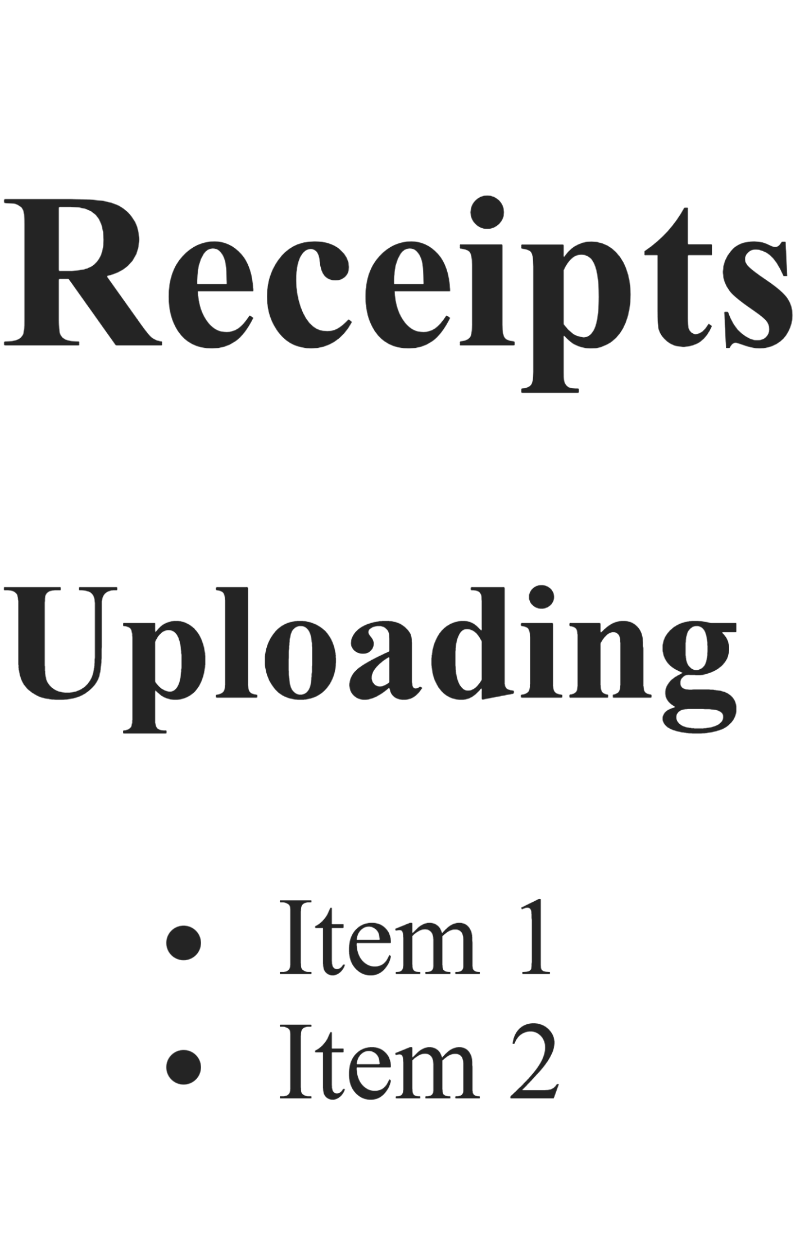
into:
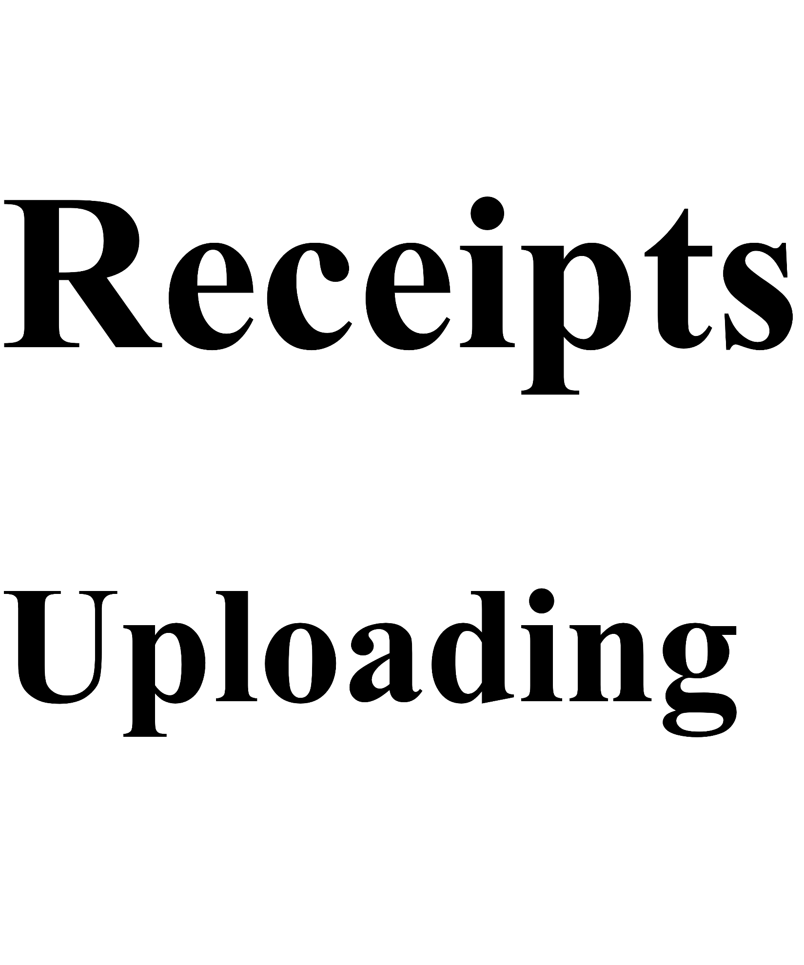
No problem.

What is Page Context?
Last night you were treating it as:
[
"Line 1",
"Line 2",
"Line 3"
]
which eventually became:
Line 1
Line 2
Line 3
stored in:
receipts.txt
The problem is:
Line 1
Line 2
Line 3
isn't HTML.
And it isn't really markdown anymore either because we already split it apart.
So HP sees:
Store receipts for bookkeeping.
This is a second line.
This is a third line.
and renders:
Store receipts for bookkeeping. This is a second line. This is a third line.
which is exactly what you observed.

I Think The Context Files Should Also Be Markdown
Instead of:
pageContexts = {
receipts: [
"Store receipts for bookkeeping.",
"",
"Second paragraph."
]
}
store:
pageContexts = {
receipts: [
"Store receipts for bookkeeping.",
"",
"Second paragraph."
]
}
exactly as you are now.
BUT...
before writing:
receipts.txt
do:
lines.join("\n")
↓
markdown parser
↓
HTML
and write:
receipts.html
`
instead.

That Gives You
Global
help/help.html
Page Context
help/pages/receipts.html

help/pages/newbusiness.html

help/pages/contacts.html
Tooltips
help/fields/tooltips.json

Why I Like This
Now developers can write:
@pc

newbusiness | ## New Business

Create your business before adding records.

- Businesses
- Contacts
- Documents

@epc
``
and get:

which HP can inject directly into the HelpBox.

Another Option
Keep:
pages/*.txt
but run markdown conversion inside HP when it's loaded.
Personally, I wouldn't.
Because then:
Global Help
and
Page Context
are handled differently.
That means more runtime work.
The Builder already exists specifically to do work ahead of time.

What I Would Do
I'd change the output structure to:
help/
│
├── help.html
│
├── pages/
│ ├── receipts.html
│ ├── contacts.html
│ └── newbusiness.html
│
└── fields/
└── tooltips.json
and run the markdown parser for:
- Global help
- Every page context
Tooltips remain plain text.

One More Thing
This means your page context syntax becomes much more valuable:
@pc

newbusiness | ## New Business

Create your business before adding records.

This is another paragraph.

@epc
Because now developers get Markdown capabilities in context help too.
Headings.
Lists.
Bold.
Links.
Etc.
Without writing HTML.

So my vote is:
✅ Keep page contexts as arrays during parsing.
✅ Join them into markdown before writing.
✅ Run them through the markdown parser.
✅ Write .html files instead of .txt.
✅ Let HP simply load and display the generated HTML.
That keeps the responsibility exactly where it belongs:
HelpLite Builder
↓
Generate HTML

HelpLite
↓
Display HTML
which is much cleaner than making HP become a markdown parser too. 😄
Yep totally agree.​‌
let's update the pagecontext writer then to do exactly that then. sadly, we won't be able to test it at all until I get home​‌

but, before we actually update the code, let's evaluate the various markdown converters that are available and decide on the proper one to use
Before we pick one, let's think about what HelpLite Builder actually needs.
You are not building:
- A blog engine
- A wiki
- MDX support
- React components in markdown
- Plug-in architecture
- Syntax highlighting
You need:
Markdown Text
↓
HTML
That's it.
So I'd evaluate them based on:
- Popularity
- Maintenance
- MIT license
- Node compatibility
- Simplicity
- Performance
- No extra bloat

Candidate 1: marked
NPM:
npm install marked
``
Usage:
const { marked } = require("marked");

const html =
marked(markdownText);
Pros:
✅ Very popular
✅ MIT
✅ Fast
✅ Simple API
✅ Works in Node
✅ Tons of examples
✅ Supports headings, lists, tables, links, code blocks
Cons:
❌ Fewer advanced plugins than some alternatives

For HelpLite Builder?
Honestly:
95% chance this is all we need.

Candidate 2: markdown-it
NPM:
npm install markdown-it
Usage:
const MarkdownIt =
require("markdown-it");

const md = new MarkdownIt();

const html =
md.render(markdownText);
Pros:
✅ Fast
✅ MIT
✅ Huge plugin ecosystem
✅ Very customizable
Cons:
❌ Slightly more setup
❌ More moving parts

For HelpLite:
Feels a little heavy for V1.

Candidate 3: remark
NPM:
npm install remark
Pros:
✅ Extremely powerful
✅ AST-based
✅ Huge ecosystem
Cons:
❌ More complex
❌ Learning curve
❌ Overkill

This is what I'd use if HelpLite Builder eventually became:
Help Compiler
with lots of transformations.
Not today.

Candidate 4: Showdown
NPM:
npm install showdown
``
Pros:
✅ Old ✅ Stable ✅ Easy
Cons:
❌ Doesn't seem to be the dominant choice anymore
❌ Smaller community than marked

My Recommendation
For HelpLite Builder:
marked
wins.
Why?
Your workflow is:
Markdown
↓
HTML
and that's literally:
const html = marked(markdown);
Done.

Future Architecture
For Page Context:
const markdown =
lines.join("\n");

const html =
marked(markdown);
Write:
help/pages/newbusiness.html
``

For Global Help:
const markdown =
parsed.markdownLines.join("\n");

const html =
marked(markdown);
Write:
help/help.html

What I'd Do Tonight
I'd make the decision:
✅ Use marked
✅ Add it as a dependency
✅ Create:
src/writers/writeHtml.js
✅ Update:
writePageContext.js
to generate:
pages/*.html
``
instead of:
pages/*.txt
Then when you get home and can test:
help.md
↓
Builder
↓
help.html
↓
pages/*.html
↓
tooltips.json
will represent the complete MVP pipeline.
And honestly, I like the discovery you made. The page context isn't really "text". It's documentation. Documentation wants markdown formatting. Once you recognize that, generating HTML for both global help and page help becomes the obvious architecture.
#3 ... yeah, no .. helplite is called "lite" for a reason. for solo devs who need a help system but don't have the time or desire to build one. Might be good for "helpfull" way, way, WAY later on though :)​‌

ok ... so still sticking with #1 then .. but we had to evaluate the others to make sure it's the right choice.​‌

let's update the pagecontext then so it used marked and we'll evaluate it at home
Agreed. For HelpLite's goals:
Simple Input
↓
Simple Builder
↓
Simple Output
marked is still the best fit. We don't need an AST, plugins, transforms, MDX, React components, or anything fancy. Just:
markdown
↓
html
and done.

Updated writePageContext.js
This version assumes you've already installed:
npm install marked
and that your parser is producing:
pageContexts = {
receipts: [
"Store receipts for bookkeeping."
],

newbusiness: [
"## Creating a Business",
"",
"Create your business before adding records.",
"",
"- Documents",
"- Contacts"
]
};
src/writers/writePageContext.js
const fs = require("fs");
const path = require("path");
const { marked } = require("marked");

function writePageContext(pageContexts) {

if (
!pageContexts ||
Object.keys(pageContexts).length === 0
) {
console.warn(
"[WARN] No page contexts found."
);

return;
}

const outputDir = path.join(
process.cwd(),
"help",
"pages"
);

fs.mkdirSync(outputDir, {
recursive: true
});

for (const [pageName, lines] of Object.entries(pageContexts)) {

const markdown = lines.join("\n");

const html = marked(markdown);

const outputFile = path.join(
outputDir,
${pageName}.html
);

fs.writeFileSync(
outputFile,
html,
"utf8"
);

console.log(
[INFO] Page context written: ${outputFile}
);

}

}

module.exports = writePageContext;

Result
Input:
@pc

newbusiness | ## Creating a Business

Create your business before adding records.

- Add Contacts
- Add Documents
- Configure Notifications

@epc
Generated:
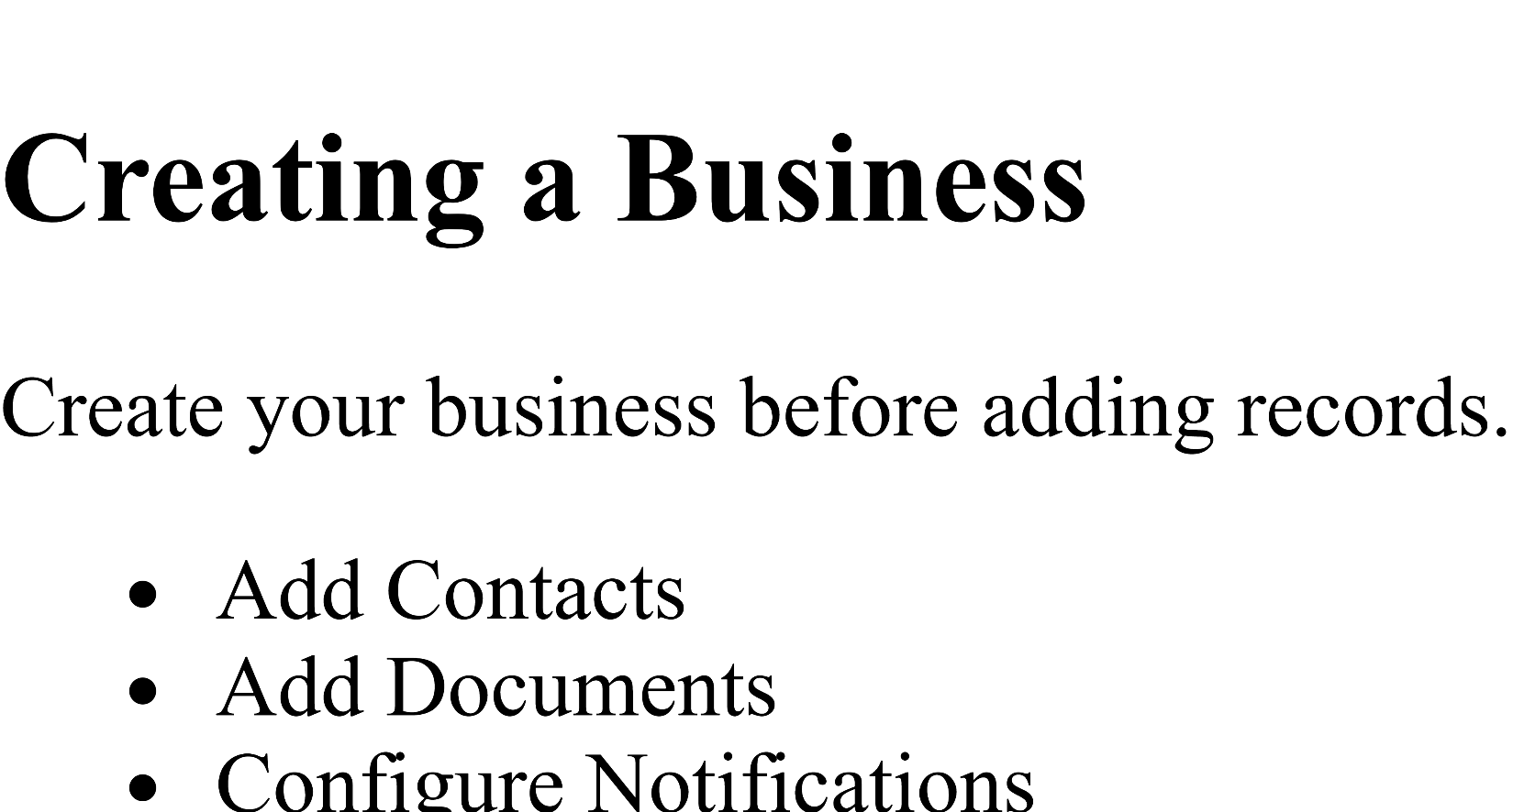
Saved as:
help/pages/newbusiness.html
which HP can simply load and display.

One Small Update
Since we're now generating HTML instead of text, I'd update the planned output structure:
help/
│
├── help.html
│
├── pages/
│ ├── receipts.html
│ ├── newbusiness.html
│ └── contacts.html
│
└── fields/
└── tooltips.json
This keeps all runtime content in its final render-ready format.

One Thing To Verify Tonight
When you test at home, I'd specifically try:
## Heading

This is a paragraph.

- Item 1
- Item 2

**Bold Text**
``
inside a page context.
If all of those render correctly in HP, you've successfully proven that:
Markdown
↓
Marked
↓
HTML
↓
HelpLite
``
works for both:
- Global Help
- Page Context Help
which means you've essentially solved the entire content-generation side of HelpLite Builder. The only major writer left after that is writeHtml.js for the global help file. 🚀
well, let's generate the last writer then and I'll test both out at home
Yep, let's finish the pipeline.
At this point we have:
help.md
↓
Parser
↓
tooltips.json
pages/*.html
↓
(help.html missing)
`
So writeHtml.js simply needs to:
- Join all markdown lines.
- Run them through marked.
- Inject the optional CSS link.
- Write help/help.html.

src/writers/writeHtml.js
const fs = require("fs");
const path = require("path");
const { marked } = require("marked");

function writeHtml(markdownLines, cssPath) {

if (!markdownLines || markdownLines.length === 0) {
console.warn(
"[WARN] No markdown content found."
);

return;
}

const markdown = markdownLines.join("\n");

const body = marked(markdown);

let html = </span><br></div><div><span attribution="{&quot;id&quot;:&quot;E64C3D4F-5E12-4514-AD9B-893A6FAFD00C&quot;,&quot;name&quot;:&quot;Copilot&quot;,&quot;oid&quot;:&quot;E64C3D4F-5E12-4514-AD9B-893A6FAFD00C&quot;,&quot;timestamp&quot;:1789485900000,&quot;dataSource&quot;:0}">&lt;!DOCTYPE html&gt;</span><br></div><div><span attribution="{&quot;id&quot;:&quot;E64C3D4F-5E12-4514-AD9B-893A6FAFD00C&quot;,&quot;name&quot;:&quot;Copilot&quot;,&quot;oid&quot;:&quot;E64C3D4F-5E12-4514-AD9B-893A6FAFD00C&quot;,&quot;timestamp&quot;:1789485900000,&quot;dataSource&quot;:0}">&lt;html lang="en"&gt;</span><br></div><div><span attribution="{&quot;id&quot;:&quot;E64C3D4F-5E12-4514-AD9B-893A6FAFD00C&quot;,&quot;name&quot;:&quot;Copilot&quot;,&quot;oid&quot;:&quot;E64C3D4F-5E12-4514-AD9B-893A6FAFD00C&quot;,&quot;timestamp&quot;:1789485900000,&quot;dataSource&quot;:0}">&lt;head&gt;</span><br></div><div><span attribution="{&quot;id&quot;:&quot;E64C3D4F-5E12-4514-AD9B-893A6FAFD00C&quot;,&quot;name&quot;:&quot;Copilot&quot;,&quot;oid&quot;:&quot;E64C3D4F-5E12-4514-AD9B-893A6FAFD00C&quot;,&quot;timestamp&quot;:1789485900000,&quot;dataSource&quot;:0}">&lt;meta charset="UTF-8"&gt;</span><br></div><div><span attribution="{&quot;id&quot;:&quot;E64C3D4F-5E12-4514-AD9B-893A6FAFD00C&quot;,&quot;name&quot;:&quot;Copilot&quot;,&quot;oid&quot;:&quot;E64C3D4F-5E12-4514-AD9B-893A6FAFD00C&quot;,&quot;timestamp&quot;:1789485900000,&quot;dataSource&quot;:0}">&lt;meta name="viewport" content="width=device-width, initial-scale=1.0"&gt;</span><br></div><div><span attribution="{&quot;id&quot;:&quot;E64C3D4F-5E12-4514-AD9B-893A6FAFD00C&quot;,&quot;name&quot;:&quot;Copilot&quot;,&quot;oid&quot;:&quot;E64C3D4F-5E12-4514-AD9B-893A6FAFD00C&quot;,&quot;timestamp&quot;:1789485900000,&quot;dataSource&quot;:0}">&lt;title&gt;Help&lt;/title&gt;</span><br></div><div><span attribution="{&quot;id&quot;:&quot;E64C3D4F-5E12-4514-AD9B-893A6FAFD00C&quot;,&quot;name&quot;:&quot;Copilot&quot;,&quot;oid&quot;:&quot;E64C3D4F-5E12-4514-AD9B-893A6FAFD00C&quot;,&quot;timestamp&quot;:1789485900000,&quot;dataSource&quot;:0}">;

if (cssPath) {
html += `<link rel="stylesheet" href="Yep, let's finish the pipeline.
At this point we have:
help.md
↓
Parser
↓
tooltips.json
pages/*.html
↓
(help.html missing)
`
So writeHtml.js simply needs to:
- Join all markdown lines.
- Run them through marked.
- Inject the optional CSS link.
- Write help/help.html.

src/writers/writeHtml.js

</head>
<body>

${body}

</body>
</html>
;</span><br></div><div><span></span><br></div><div><span attribution="{&quot;id&quot;:&quot;E64C3D4F-5E12-4514-AD9B-893A6FAFD00C&quot;,&quot;name&quot;:&quot;Copilot&quot;,&quot;oid&quot;:&quot;E64C3D4F-5E12-4514-AD9B-893A6FAFD00C&quot;,&quot;timestamp&quot;:1789485900000,&quot;dataSource&quot;:0}"> const outputFile = path.join(</span><br></div><div><span attribution="{&quot;id&quot;:&quot;E64C3D4F-5E12-4514-AD9B-893A6FAFD00C&quot;,&quot;name&quot;:&quot;Copilot&quot;,&quot;oid&quot;:&quot;E64C3D4F-5E12-4514-AD9B-893A6FAFD00C&quot;,&quot;timestamp&quot;:1789485900000,&quot;dataSource&quot;:0}"> process.cwd(),</span><br></div><div><span attribution="{&quot;id&quot;:&quot;E64C3D4F-5E12-4514-AD9B-893A6FAFD00C&quot;,&quot;name&quot;:&quot;Copilot&quot;,&quot;oid&quot;:&quot;E64C3D4F-5E12-4514-AD9B-893A6FAFD00C&quot;,&quot;timestamp&quot;:1789485900000,&quot;dataSource&quot;:0}"> "help",</span><br></div><div><span attribution="{&quot;id&quot;:&quot;E64C3D4F-5E12-4514-AD9B-893A6FAFD00C&quot;,&quot;name&quot;:&quot;Copilot&quot;,&quot;oid&quot;:&quot;E64C3D4F-5E12-4514-AD9B-893A6FAFD00C&quot;,&quot;timestamp&quot;:1789485900000,&quot;dataSource&quot;:0}"> "help.html"</span><br></div><div><span attribution="{&quot;id&quot;:&quot;E64C3D4F-5E12-4514-AD9B-893A6FAFD00C&quot;,&quot;name&quot;:&quot;Copilot&quot;,&quot;oid&quot;:&quot;E64C3D4F-5E12-4514-AD9B-893A6FAFD00C&quot;,&quot;timestamp&quot;:1789485900000,&quot;dataSource&quot;:0}"> );</span><br></div><div><span></span><br></div><div><span attribution="{&quot;id&quot;:&quot;E64C3D4F-5E12-4514-AD9B-893A6FAFD00C&quot;,&quot;name&quot;:&quot;Copilot&quot;,&quot;oid&quot;:&quot;E64C3D4F-5E12-4514-AD9B-893A6FAFD00C&quot;,&quot;timestamp&quot;:1789485900000,&quot;dataSource&quot;:0}"> fs.writeFileSync(</span><br></div><div><span attribution="{&quot;id&quot;:&quot;E64C3D4F-5E12-4514-AD9B-893A6FAFD00C&quot;,&quot;name&quot;:&quot;Copilot&quot;,&quot;oid&quot;:&quot;E64C3D4F-5E12-4514-AD9B-893A6FAFD00C&quot;,&quot;timestamp&quot;:1789485900000,&quot;dataSource&quot;:0}"> outputFile,</span><br></div><div><span attribution="{&quot;id&quot;:&quot;E64C3D4F-5E12-4514-AD9B-893A6FAFD00C&quot;,&quot;name&quot;:&quot;Copilot&quot;,&quot;oid&quot;:&quot;E64C3D4F-5E12-4514-AD9B-893A6FAFD00C&quot;,&quot;timestamp&quot;:1789485900000,&quot;dataSource&quot;:0}"> html,</span><br></div><div><span attribution="{&quot;id&quot;:&quot;E64C3D4F-5E12-4514-AD9B-893A6FAFD00C&quot;,&quot;name&quot;:&quot;Copilot&quot;,&quot;oid&quot;:&quot;E64C3D4F-5E12-4514-AD9B-893A6FAFD00C&quot;,&quot;timestamp&quot;:1789485900000,&quot;dataSource&quot;:0}"> "utf8"</span><br></div><div><span attribution="{&quot;id&quot;:&quot;E64C3D4F-5E12-4514-AD9B-893A6FAFD00C&quot;,&quot;name&quot;:&quot;Copilot&quot;,&quot;oid&quot;:&quot;E64C3D4F-5E12-4514-AD9B-893A6FAFD00C&quot;,&quot;timestamp&quot;:1789485900000,&quot;dataSource&quot;:0}"> );</span><br></div><div><span></span><br></div><div><span attribution="{&quot;id&quot;:&quot;E64C3D4F-5E12-4514-AD9B-893A6FAFD00C&quot;,&quot;name&quot;:&quot;Copilot&quot;,&quot;oid&quot;:&quot;E64C3D4F-5E12-4514-AD9B-893A6FAFD00C&quot;,&quot;timestamp&quot;:1789485900000,&quot;dataSource&quot;:0}"> console.log(</span><br></div><div><span attribution="{&quot;id&quot;:&quot;E64C3D4F-5E12-4514-AD9B-893A6FAFD00C&quot;,&quot;name&quot;:&quot;Copilot&quot;,&quot;oid&quot;:&quot;E64C3D4F-5E12-4514-AD9B-893A6FAFD00C&quot;,&quot;timestamp&quot;:1789485900000,&quot;dataSource&quot;:0}"> [INFO] Global help written: ${outputFile}`
);
}

module.exports = writeHtml;

build.js
At the top:
const writeHtml = require(
"./writers/writeHtml"
);
Near the bottom:
writeTooltips(parsed.tooltips);
writePageContext(parsed.pageContexts);
writeHtml(
parsed.markdownLines,
parsed.cssPath
);

Expected Output Structure
After running:
npm run build-help
you should end up with:
help/
│
├── help.html
│
├── pages/
│ ├── receipts.html
│ ├── newbusiness.html
│ └── contacts.html
│
└── fields/
└── tooltips.json

What I'd Test Tonight
Global Help
Try:
# Global Help

## Setup

This is a paragraph.

- Item 1
- Item 2

**Bold Text**
Verify:
- H1 renders
- H2 renders
- Lists render
- Bold renders
- CSS applies

Page Context
Try:
@pc

newbusiness | ## Creating a Business

This is a paragraph.

- Documents
- Contacts

@epc
Verify:
- Heading renders
- Paragraph renders
- List renders

Tooltips
Verify:
{
"receiptAmount": "Amount shown on receipt."
}
still builds correctly.

If all three pass, you will have proven the complete HelpLite Builder MVP:
Single Help Source
↓
Builder
↓
Global Help HTML
Page Context HTML
Tooltip JSON
↓
HelpLite Runtime
Which is actually a pretty significant milestone for a weekend project. 🚀
if (cssPath) {
29
html += `<link rel="stylesheet" href="{{promptBody}}
30
</head>
31
<body>​‌

this is a bit malformed .. shouldn't be an if here since we are validating that we have a CSS initially and then passing it in as a parameter.​‌

should it not be:​‌
<!DOCTYPE html>
<html lang="en">
<head>
<meta charset="UTF-8">
<meta name="viewport" content="width=device-width, initial-scale=1.0">
<title>Help</title>
<link rel="stylesheet" href="'${cssPath}'"
</head>
<body>
'${body}'
</body>
</html>
`;
if (cssPath) {
29
html += `<link rel="stylesheet" href="{{promptBody}}
30
</head>
31
<body>​‌

this is a bit malformed .. shouldn't be an if here since we are validating that we have a CSS initially and then passing it in as a parameter.​‌

should it not be:​‌
<!DOCTYPE html>
<html lang="en">
<head>
<meta charset="UTF-8">
<meta name="viewport" content="width=device-width, initial-scale=1.0">
<title>Help</title>
<link rel="stylesheet" href="'${cssPath}'"
</head>
<body>
'${body}'
</body>
</html>
`;
Yes, you're right. Looking at it again, my generated example got mangled and there's no real reason for the conditional if your validation guarantees a CSS path.
For V1, I'd actually make the CSS required and generate the entire document at once.
Something more like:
JavaScript
1
const html = `
2
<!DOCTYPE html>
3
<html lang="en">
4
<head>
5
<meta charset="UTF-8">
6
<meta name="viewport" content="width=device-width, initial-scale=1.0">
7
<title>Help</title>
8
<link rel}
9
</head>
10
<body>
11

12
${body}
13

14
</body>
15
</html>
16
`;
Show more lines
A few tweaks though:
1. Remove the extra quotes
You have:
1
<link rel="stylesheet" href="'${cssPath}
Show more lines
That would generate:
1
<link rel="stylesheet" href="'/styles
Show more lines
Notice the embedded quotes.
Should be:
1
${cssPath}
Show more lines
or
1
${cssPath}
Show more lines

2. No quotes around ${body}
You wrote:
1
'${body}'
2
``
Show more lines
That would literally output:
1
'<h1>Help</h1>'
Show more lines
which isn't what we want.
Use:
1
${body}
Show more lines
instead.

3. Consider Validation
Right now you're validating:
JavaScript
1
@link(...)
Show more lines
exists.
Which means:
JavaScript
1
cssPath
Show more lines
should never be:
JavaScript
1
null
Show more lines
by the time we get here.
So I agree:
JavaScript
1
if (cssPath)
Show more lines
can go away entirely.

Final Version
I'd probably do:
JavaScript
1
const html = `<!DOCTYPE html>
2
<html lang="en">
3
<head>
4
<meta charset="UTF-8">
5
<meta name="viewport" content="width=device-width, initial-scale=1.0">
6
<title>Help</title>
7
<link rel="stylesheet" href="${css</body>
8
</html>`;
Show more lines
Then:
JavaScript
1
fs.writeFileSync(
2
outputFile,
3
html,
4
"utf8"
5
);
Show more lines

One thing I would test tonight:
Markdown
1
# Global Help
2

3
## Test Heading
4

5
This is **bold** text.
6

7
- Item One
8
- Item Two
Show more lines
If marked generates:
1
<h1>Global Help</h1>
2
<h2>Test Heading</h2>
3
<p>This is <strong>bold</strong> text.</p>
4
<ul>
5
...
6
</ul>
Show more lines
inside your generated help.html, then your entire pipeline is basically proven.
At that point you'll have:
Plain Text
1
help.md
2
↓
3
Builder
4
├── help.html
5
├── pages/*.html
6
└── fields/tooltips.json
7
``
Show more lines
which is exactly what HelpLite needs to consume. That's a pretty solid MVP. 🚀
ok - so the other thing we'll need to do, either here or in HP, is we'll need to add the global help search ... but we'll figure that out at home as well .... it's working in-app to add the search but in a new tab it's not adding it ... so we'll figure that out as well.​‌

other than that, I think I just need to bring over the cli yml files, work up the readme and other docs and then we can release both of these together.
Honestly, that's sounding pretty close to a real v1 release candidate.
On Search
I actually wouldn't solve it in Builder.
Builder's job should remain:
help.md
↓
Generate
↓
help.html
pages/*.html
tooltips.json
Search feels like a HelpLite runtime responsibility because it's UI behavior, not content generation.
So I'd lean toward:
HelpLite Builder
↓
Produces Help Content

HelpLite
↓
Displays Help Content
↓
Provides Search
The only Builder involvement I could see is maybe generating a search index later:
search.json
containing:
[
{
"title": "Receipts",
"keywords": ["receipts", "uploading", "categories"]
}
]
But honestly I wouldn't do that until it's actually needed.

The New Tab Problem
My guess without seeing the code:
The in-app version probably has access to:
window.HelpLite
``
or
document
or some existing search initialization logic.
The new tab version is likely:

being opened independently and never getting the search initialization script.
I'd investigate:
DOMContentLoaded
and verify the search code is actually executing in the standalone page.
My suspicion is you'll find something simple.

Releasing PK + HP
If I look at where you are now:
PrefKeeper
✅ Public repo
✅ npm package
✅ Documentation cleaned
✅ Screenshots added
✅ Logo added
✅ Footer attribution
✅ Issue backlog started

HelpLite
✅ Runtime working
✅ Global help working
✅ New-tab help working
✅ Builder concept working
✅ Parser working
✅ Validation working
✅ Tooltip generation working
✅ Page context generation working
✅ Global help generation working
🚧 Final testing
🚧 Docs
🚧 CI

That's actually a pretty strong place to be.

What I'd Focus On Before Release
High Priority
- Verify generated HTML actually renders correctly.
- Verify page context HTML loads correctly in HP.
- Verify tooltip JSON is consumed correctly.
- Test with intentionally bad data.
- Read the README from top to bottom.

Medium Priority
- Bring over CI YAML files.
- Bring over issue templates.
- Bring over PR templates.
- Add labels.
You already solved these once with PK.
No need to reinvent them.

Low Priority
- Search enhancements.
- Multiple build types.
- Sidebar navigation.
- Builder improvements.
Those can all wait.

My Gut Feeling
A few weeks ago:
PrefKeeper
was your proof that you could build and release a reusable package.
Now:
HelpLite
is becoming proof that you can take a need from CK, extract it, and turn it into a standalone reusable module.
That's actually a pretty important milestone.
And if you release:
@beam/prefkeeper
@beam/helplite
before the end of the year, you've already started building the ecosystem you keep talking about.
So yes, I think your immediate roadmap is spot on:
- Test at home.
- Verify generated HTML.
- Fix any rendering issues.
- Copy over CI/docs infrastructure.
- Finish README.
- Release.
Then let people use it while you get back to the much bigger job:
CorpKeeper Wireframes
Because unlike PK and HP, that's still the main event. 😄🚀

